Evaluation of Botryzen in the control of Grey mold (Botrytis cinerea) in Ginseng

General Trial Information
- Tester : Korea Plants Environmental Research Laboratory (CRO)
- Sponsor : Atlatech Co., Ltd.
- Test Location : Cheongwon, Chungbuk
- Test period : 01.08.2014 ~ 31.08.2014

Objectives
- To determine the efficacious dosage of Botryzen against Grey mold (Botrytis cinerea) in Ginseng
- To evaluate control efficacy of Botryzen against Soft rot (Botrytis cinerea) Ginseng
- To assess the phytotoxicity of Botryzen on Ginseng

Methods
- Target pest : Grey mold (Botrytis cinerea)
- Crop : Ginseng (Panax ginseng) var. ‘local variety’
- Treatments
Product | Efficacy |  | Phytotoxicity
 | Dilution rate & Dosage | Application time & method  (dates for application) | Standard dosage | Double dosage
1. Botryzen | x1,000 | 3 times folia application with 7 days interval from the early stage of disease outbreak  (August 1, 8 and 15) | x1,000 | x500-
2. Botryzen | x500
3. BETF 1401 | x3,000 |  | x3,000 | x1,500
4. BETF 1401 | x1,500 |  | - | -
5. BETF 1403 | x1,000 |  | x1,000 | x500
6. BETF 1403 | x500 |  | - | -
7. Fludioxonil 20% SC | x2,000
8. Untreated Control | - | -
<Note> Plots for the assessment of phytotoxicity were sprayed on August 1.

- Application equipment and spray volume
Application equipment | Maruyama MS0735
Spray Volume | 1,200 L/ha

- Cultivation details
- Cultivation type : Open field, cultivate under the plastic rain screen
- Age of Ginseng : 4 years
- Planting spacing : 15 x 15 cm
- There were no sprays of any pesticide during test period

- Study plot design and size
(Randomized Completed Block Design, 3 replications)
Classification | Nr. of Treatments | Nr. of Replications | Total nr. of Plots | Treated Plot Area | Treated  Study Area
Efficacy | 8 | 3 | 24 | 10 sq.m | 240 sq.m
Phytotocity | 7 | 3 | 21 | 1 sq.m | 21 sq.m

- Climatic conditions (refer to Cheongju Weather Station)
Date | Rainfall  (mm) | Temperature ($°$C)  high / low | Average  Temperature (°C)
July 31 | 21.0 | 36.0 / 23.2 | 28.7
August 1 | - | 34.1 /23.5 | 29.1
August 2 | 11.5 | 33.1 / 24.5 | 29.3
August 7 | 17.0 | 23.4 / 20.4 | 21.8
August 8 | - | 29.1 / 21.7 | 25.2
August 9 | - | 30.7 / 20.9 | 25.7
August 14 | 5.0 | 23.0 / 20.5 | 21.6
August 15 | - | 29.9 / 20.7 | 24.5
August 66 | -- | 32.4 / 22.3 | 26.7
<note> Folia sprays were made on August 1, 8 and 15..

Assessment Method and Date

Classification | Assessment | Nr. of assessment | Assessment date | Assessmen method
Efficacy | Infected leaves | 1 | August 22 | Count infected leaves among 100 leaves per plot on 7 days after final application
Phytotoxicity | Crop damage | 3 | August 4, 6 and 8 | Visual rating of crop damage on 3, 5, 7 days after application

Results
- Efficacy
Product | Infected leaves (%) |  |  |  | Significance  (DMRT 95%) | Control Value  (%)
 | 1R | 2R | 3R | Mean
1. Botryzen | 5.0 | 6.1 | 2.8 | 4.6 | b | 83.1
2. Botryzen | 4.1 | 3.0 | 2.7 | 3.3 | b | 87.9
3. BETF 1401 | 12.4 | 2.9 | 9.3 | 8.2 | b | 69.9
4. BETF 1401 | 10.1 | 9.1 | 5.8 | 8.3 | b | 69.5
5. BETF 1403 | 11.9 | 9.1 | 5.3 | 8.8 | b | 67.6
6. BETF 1403 | 10.5 | 11.9 | 7.0 | 9.8 | b | 64.0
7. Fludioxonil 20%SC | 1.7 | 6.1 | 2.0 | 3.3 | b | 87.9
8. Untreated control | 22.4 | 23.6 | 35.6 | 27.2 | a | -
C.V.(%) = 42.5

- Phytotoxicity (assessed on 5, 7, 14 days after application)
Product | Crop | Degree of Crop Damage (0~5) |  | Remark
 |  | Standard  Dosage | Double  Dosage
Botryzen | Ginseng  (‘local variety’) | 0 | 0 | No damage
BETF 1401 |  | 0 | 0 | “
BETF 1403 |  | 0 | 0 | “

Summary and Conclusion
- This study was performed according to the ‘Criteria and Method of Study for the product registration of agrochemicals’. Efficacy of study products were evaluated with the percentage of infected leaves in the treated plot compared to that of untreated control at the 7 days after the final application.

- Study plot design was randomized complete block design with 3 replications. For the evaluation of efficacy of study products the infected leaves over the 100 leaves per study plot were counted and converted to the percentage of infected leaves. Significance by treatment was analyzed by ‘Duncan’s multiple range test’ at 95% credit level

- As the percentage of infected leaves in the untreated control plot was 27.2%, it was enough to assess the efficacy of each treatment.

- Control values of Botryzen were 83.1% at x1,000 and 87.9% at x500 respectively, and there was no significant difference between dilution rates, and to the reference product.

- BETF 1401 showed 69.9% and 69.5% control value respectively, and there was no significant difference between x3,000 and x1,500 dilution rates. There was no significant difference to reference product.

- BETF 1403 showed 67.6% control value in treatment x1,000 plot and 64.0% in treatment x500 plot. There was no significant difference to the reference product in efficacy.

- All three study product showed no crop damage at both of standard and double dosage

Pictures
Overview on study site
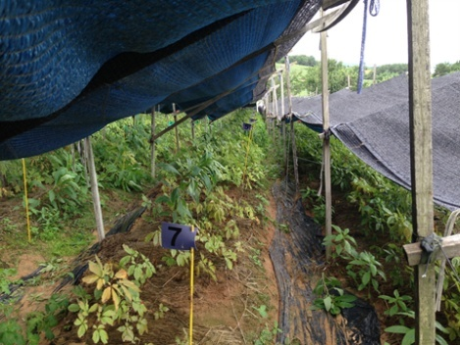

Botryzen x1,000 Botryzen x500
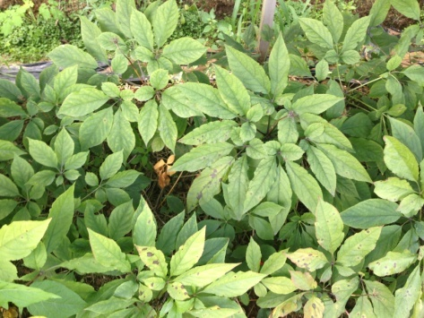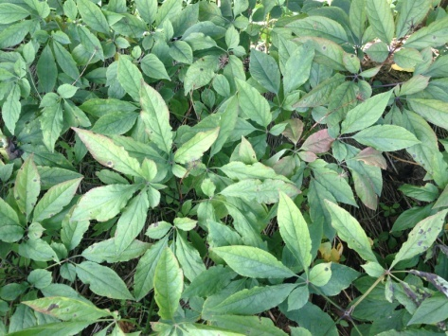

BETF 1401 x3,000 BETF 1401 x1,500
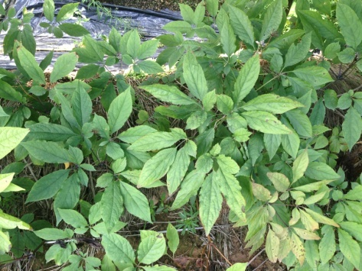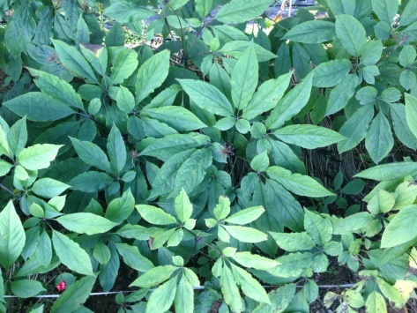

BETF 1403 x1,000 BETF 1403 x500
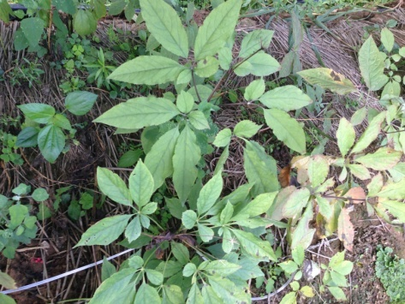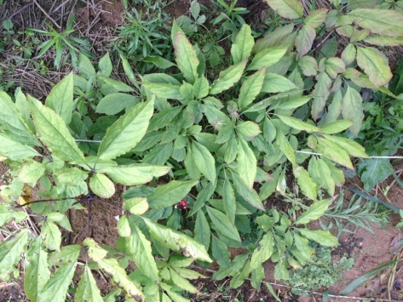

Fludioxonil x2,000l
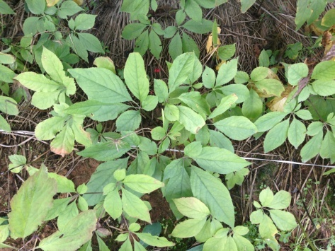

Untreated Control Untreated Control
