Biological control of botrytis post-harvest storage rot in Blueberry cv. ‘Maru’ during 2004-05

S.M. Hoyte, P.A.G Elmer and S. Solomona

5 August 2005

EXECUTIVE SUMMARY
Background
Post-harvest botrytis rot of blueberries, caused by Botrytis cinerea, has been highlighted as a potentially significant cause of crop loss, particularly for the cultivar ‘Maru’. Three biological-based spray schedules were evaluated for control of botrytis.

Methods
A trial with four treatments was carried out on rabbiteye blueberry (Vaccinium ashei cv. ‘Maru’) in the Hawke’s Bay Gourmet Blueberry property.
- Nil control.
- Botry-Zen® (Ulocladium oudemansii) / BZII (Chitosan) during flowering, BZII / HRAB (Aureobasidium) during fruit development.
- HRE342 (Epicoccum nigrum) during flowering, RuaDRH (Trichoderma spp.) during fruit development.
- Serenade® (Bacillus subtilis) during flowering and fruit development.

Treatments were applied using a knapsack mist blower. Green juvenile berry and pre-harvest fruit samples were processed using the Overnight Freezing and Incubation Technique (ONFIT) to determine incidence of latent infections of botrytis. A single sample of ripe fruit was collected during the harvest period, cold stored for 7 days and incubated at 20ºC for 10 days to observe the expression of botrytis rots. The incidence of rots was assessed every 3–4 days.

Results
- All three BCA treatments reduced the incidence of post-harvest botrytis rots after 3, 6 and 10 days incubation at 20ºC, compared to the nil treatment.
- The only statistically significant reduction in the incidence of post-harvest botrytis rots was in the Botry-Zen/BZII/HRAB and HRE342/RuaDRH treatments after 10 days incubation at 20ºC.
- It cannot be determined from this trial which of the individual BCAs used in treatments 2 and 3 were achieving disease suppression.

Recommendations
- Is it crucial that this same trial be carried out again to demonstrate that this result is repeatable.
- Further spray trials should seek to identify which of the biological components used during 2004-05 are providing the observed suppression of botrytis rots.
- Determine if weather-based (infection period) timing of sprays is feasible in order to minimise the number of applications required.
- Dormant season control (e.g. on twigs and weeds) of botrytis warrants investigation as a means of reducing the carry-over of inoculum between seasons.
- Investigate in more detail the possible linkage between the incidence of botrytis from early season ONFIT samples and the incidence of botrytis post-harvest rot, as a potential means of determining botrytis risk levels prior to harvest.

For further information contact

Dr Stephen Hoyte
Ruakura Research Centre, East St, Hamilton
ph: 07 858 4719 or email: shoyte@hortresearch.co.nz

INTRODUCTION
Post-harvest botrytis rot of blueberries, caused by botrytis cinerea, has been highlighted as a potentially significant cause of crop loss, particularly for the cultivar ‘Maru’, which represents a large proportion of the crop production for Gourmet Blueberry. Botrytis is also considered to be one of the most important diseases of blueberry in the US and Chile (Ciampi, 2002; Schilder et al., 2002). The corolla of the blueberry flower is susceptible to botrytis from the pink bud pre-bloom stage through to fully open and during senescence (Hildebrand et al., 2001). Whole flowers and clusters can become blighted when disease-favourable conditions of surface wetness or high humidity extend for >24 h.

Latent infections by B. cinerea have been reported in several fruits (e.g. grapes, strawberries) that develop post-harvest botrytis rots (Keller et al., 2003). The occurrence of latent infection of blueberry by B. cinerea has not been extensively studied. Although an epidemiological link between early season infection and post-harvest rots has been shown for crops such as grapes, this is not yet the case with blueberry. In an attempt to identify possible non-fungicide control measures against botrytis fruit rot; three biological-based spray schedules were evaluated during 2004-05.

AIM
To evaluate the efficacy of three biological spray programs against botrytis rot in rabbiteye blueberry cv. ‘Maru’.

METHODS
A spray trial using combinations of biological control agents (BCAs) was carried out at the Gourmet Blueberry property, Flaxmere, Hawke’s Bay during the 2004-05 growing season. A randomised complete block trial layout was used across three rows of cv. ‘Maru’, each row containing a replicate plot for each treatment. Each plot consisted of ten adjacent bushes separated five buffer bushes within the row and each row with treatments was separated by a buffer row of bushes. The trial used five different biological control agents (Table 1), compared to a nil control. The biological control agents were combined to give a schedule of three treatments to control botrytis during flowering and fruit development (Table 2). All sprays were applied using a mist-blower knapsack sprayer using a pressure of 20–25 psi and a water rate of 800–1000  ha⁻¹. The adjuvant Nu-Film 17 (30 ml/100) was used with all treatments.

Table 1. Products, active ingredients and application rates for botrytis trial 2004-05.
Biological control agent | Active ingredient | Rate of application  (product)
BOTRY-Zen® | Ulocladium oudemansii | 2 x 10⁶ spores/ml
BZII | Chitosan | 20 g/100 
HRAB | Yeast-like fungus | 2 x 10⁷ spores/ml
HRE342 | Epicoccum nigrum | 2 x 10⁵ spores/ml
RuaDRH | Trichoderma spp. ¹ | 2 x 10⁷ spores/ml
Serenade® | Bacillus subtilis ² | 2 x 10⁶ spores/ml
¹ mixture of six strains.
² strain (QST713).
Table 2. Timing of spray applications for control of botrytis in Blueberry ‘Maru’ during 2004/05.
Treat.  No. | Application dates
Treat.  No. | Flowering |  |  | Fruit development
 | 28-Oct-04 | 4-Nov-04 | 11-Nov-04 | 25-Nov-04 | 15-Dec-04 | 13-Jan-05
1 | nil | nil | nil | nil | nil | nil
2 | BZ/BZII | BZ/BZII | BZ/BZII | HRAB/BZII | HRAB/BZII | HRAB/BZII
3 | HRE342 | HRE342 | HRE342 | RuaDRH | RuaDRH | RuaDRH
4 | B. subtilis | B. subtilis | B. subtilis | B. subtilis | B. subtilis | B. subtilis

The incidence of latent botrytis infections in the different treatments was assessed in juvenile green ‘pea size’ berries (sampled 23 November 2004) and pre-harvest berries (sampled 25 January 2005), using the Overnight Freezing and Incubation Technique (ONFIT) (http://tjm.uckac.edu/TJM-Site/onfit/ONFIT.htm). The ONFIT process involves eliminating microorganisms on the fruit surface by surface sterilisation, then killing the fruit tissues by overnight freezing. This allows microorganisms within the fruit tissue to develop when incubated at room temperature.

Berries for ONFIT were first surface sterilised by dipping in 95% ethanol for 30 seconds, 1% sodium hypochlorite for 5 minutes, and 95% ethanol for 30 seconds, then rinsed in running tap water. Berries were then placed onto trays and frozen at –18ºC for 24 h. After removal from the freezer, trays were placed inside plastic bags and incubated at 20ºC. The number of berries developing botrytis rots was assessed after 7 days and expressed as a percentage.

To determine the development of botrytis rots in mature fruit under simulated commercial conditions, a fruit sample of 160 berries per plot was collected from the trial on 14 February 2005. These were placed into trays inside a large plastic bag, held in a chiller (4–6ºC) for 7 days, and then held at 20ºC. Data is presented as the incidence of berries with visible botrytis sporulation, recorded after 3, 6 and 10 days. Berries with rot symptoms were removed from the trays at each assessment date to minimise nesting (spreading of botrytis between berries in the tray). Data was analysed as a binomial generalised linear model in the statistical package Genstat® with allowance for extra-binomial variation. T-test comparisons with the nil treatment were done using standard errors from the generalised linear model.

RESULTS and DISCUSSION
Early-season and pre-harvest latent infections
The incidence of latent botrytis infections in green and nearly ripe blueberries, as determined by the ONFIT process, is shown in Figure 1. There was a 19% incidence of latent botrytis infections in the nil treatment at the end of November (ONFIT 1), compared to 0.3–4.7% in the three BCA treatments, suggesting there had been significant suppression of early season latent infections in the berries. However, fruit sampled pre-harvest (ONFIT 2) had only 2.3% incidence of latent botrytis infections in the nil treatment, while the three BCA treatments were similar, ranging from 1.0–5.7%.

The relationship between early and late-season infection of blueberries by botrytis, and the incidence of post-harvest storage rots, is uncertain. It is also unclear why the level of latent infection declined substantially in the nil treatment although there are reports of early season latent infections which decline over time due to a variety of host defence factors (Bais et al., 2000).

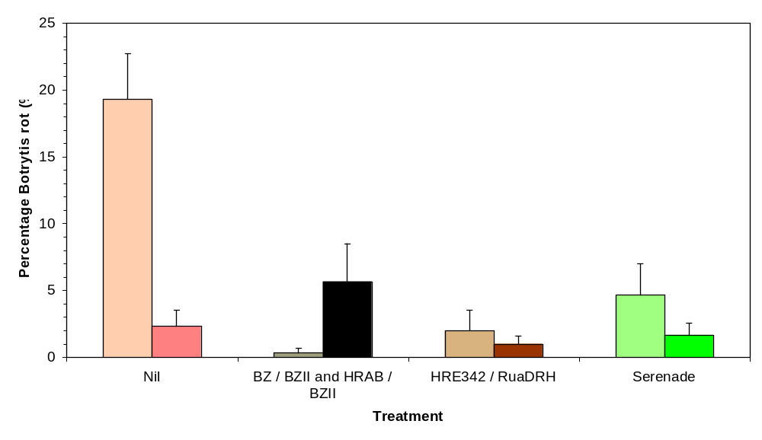
Figure 1. Percentage incidence of botrytis rots developing on Blueberries cv. ‘Maru’ sampled on 23 November 2004 (Onfit 1, diagonal shaded bars) and 25 January 2005 (Onfit 2, solid bars), after 7 days incubation in humid trays, following ONFIT processing. Whiskers are standard error of the mean.

Post-harvest botrytis rots
The incidence of botrytis rots on harvested fruit stored at 20ºC is shown in Figure 2. In the nil treatment the incidence of botrytis rots increased steadily during the 10-day assessment period, rising from 12% at 3 days to 32% after 10 days. This indicates there was considerable disease pressure with the trial block and highlights the potential for significant crop loss from this disease. Typical sporulation was visible on the berries with botrytis rot (Figure 3).

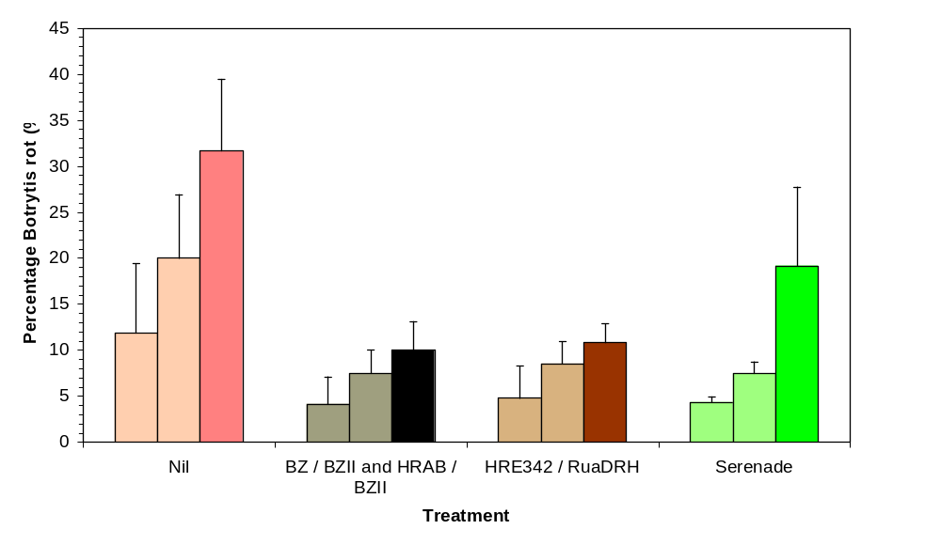
Figure 2. Percentage incidence of botrytis rots on Blueberries cv. ‘Maru’ on fruit sampled at harvest, cold stored for 7 days and incubated at 20ºC for 3 days (dotted bars), 6 days (diagonal bars) and 10 days (filled bars) during February 2005. Whisker lines are standard error of the mean.
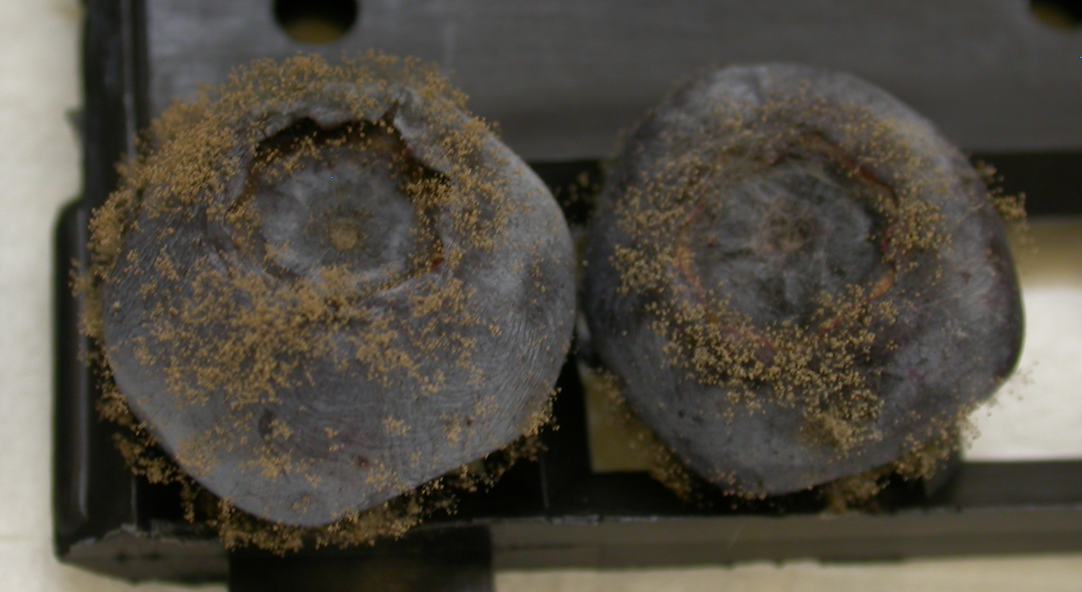
Figure 3. Sporulation of Botrytis cinerea on ‘Maru’ blueberries after 6 days incubation at 20ºC.

The incidence of botrytis rots was not significantly reduced (P>0.10) by any treatment on the 3-day assessment (Figure 2). After 6 days incubation the three BCA treatments (Botry-Zen/BZII/HRAB, HRE342/RuaDRH and Serenade) did reduce the incidence of botrytis rots compared to the nil, but only at P<0.10, i.e. 90% confidence level. After 10 days incubation the Botry-Zen/BZII/HRAB and HRE342/RuaDRH treatments were significantly lower (P<0.05) than the nil treatment, and the Serenade treatment was not significantly lower (P>0.10) than the nil (Figure 2). The incidence of botrytis rots on blueberries sampled early season and processed using ONFIT closely matched the incidence of rots in the harvest samples (Figure 1 and 2).

These results indicate that each of the BCA treatments has provided some level of botrytis suppression, especially the Botry-Zen/BZII/HRAB, HRE342/RuaDRH treatments. It is now important to determine which of the individual BCA components in these treatments is responsible for the disease control observed in this trial.

Recommendations
- Is it crucial that this same trial be carried out again to demonstrate that this result is repeatable.
- Further spray trials should seek to identify which of the biological components used during 2004-05 are providing the observed suppression of botrytis rots.
- Determine if weather-based (infection period) timing of sprays is feasible in order to minimise the number of applications required.
- Dormant season control (e.g. on twigs and weeds) of botrytis warrants investigation as a means of reducing the carry-over of inoculum between seasons.
- Investigate in more detail the possible linkage between the incidence of botrytis from early season ONFIT samples and the incidence of botrytis post-harvest rot, as a potential means of determining botrytis risk levels prior to harvest.

References

Bais, A.J., Murphy, P.J. & Dry, I.B. (2000). The molecular regulation of stilbene phytoalexin biosynthesis in Vitis vinifera during grape berry development. Australian Journal of Plant Physiology 27, 425-433.

Ciampi, L. (2002). Influence of crop residues and environmenatal factors on Botrytis cinerea in blueberry cultivation in Chile. In: Atti, Giornate fitopatologiche, Baselga di Pine, vol. 2 (ed. A. Brunelli and A. Canova), pp. 261-262. Universidad Austral de Chile, Valdivia, Trento, Italy.

Hildebrand, P.D., McRae, K.B. & Lu, X. (2001). Factors affecting flower infection and disease severity of lowbush blueberry by Botrytis cinerea. Canadian Journal of Plant Pathology 23, 364-370.

Keller, M., Viret, O. & Cole, M. (2003). Botrytis cinerea infection in grape flowers: Defense reaction, latency and disease expression. Phytopathology 93, 316-322.

Schilder, A.M.C., Gillett, J.M. & Woodworth, J.A. (2002). The kaleidoscopic nature of blueberry fruit rots. Acta Horticulturae 574, 81-83.

