RESEARCH AND DEVELOPMENT

PROJECT REPORT

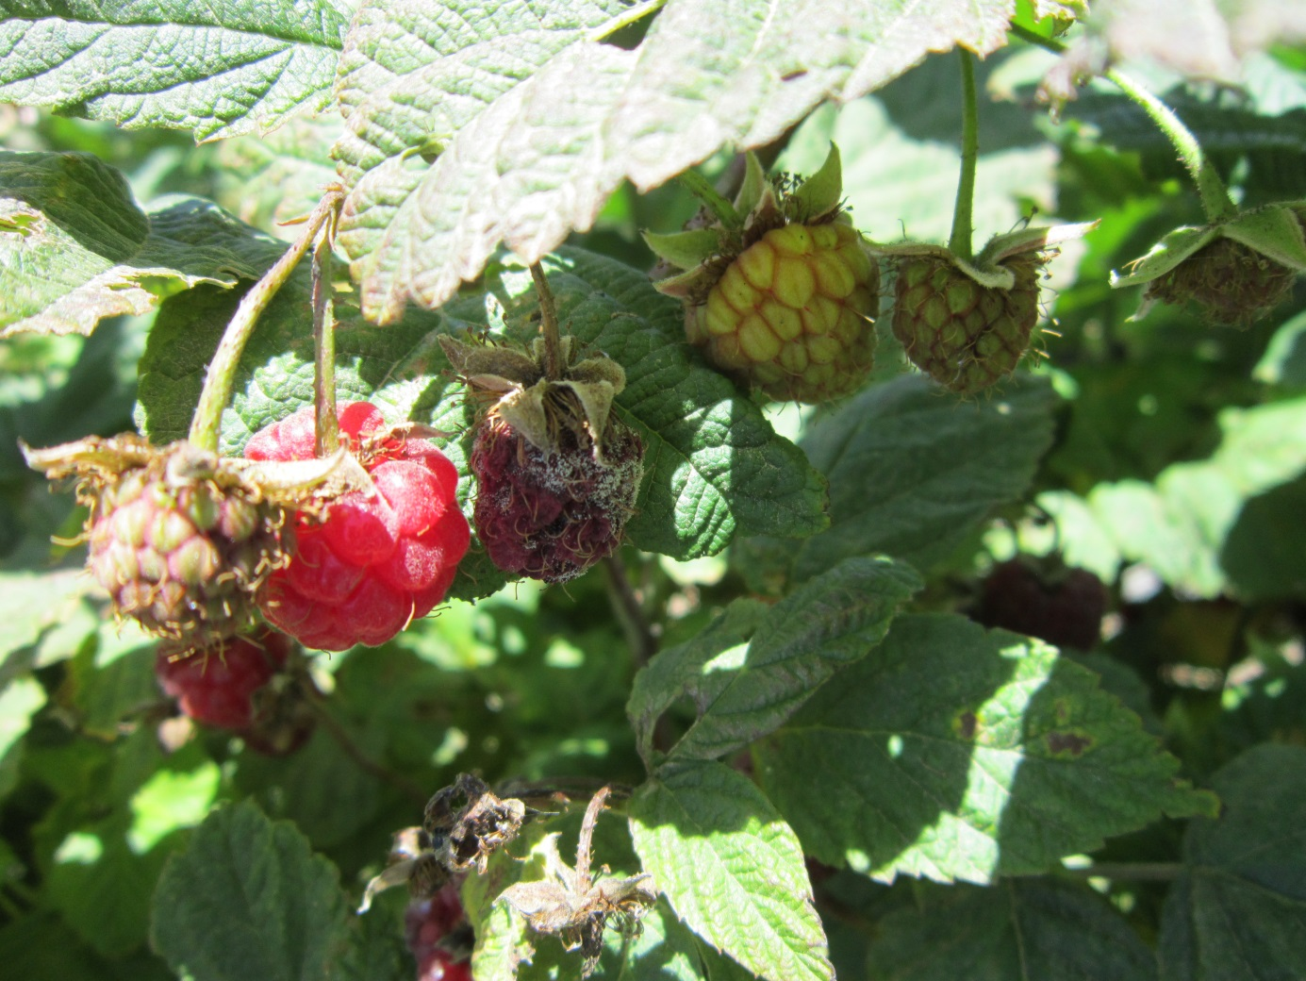

Efficacy of Zen-O-Spore for control of *Botrytis* in Raspberries

**Trial ID: ENA1301**

**Prepared for:**

Duane Ewing / Ewing & Associates

**Prepared by:**



Summer/2013

Table of Contents

ABSTRACT Page 3

MATERIALS AND METHODS Page 4

RESULTS

Table/Graph 1. *Botrytis* Incidence Page 6

Table/Graph 2. *Rhizopus* Incidence Page 7

Table/Graph 3. Other disease Pest Incidence Page 8

Table/Graph 4. AUDPC Page 9

Table/Graph 5. % Control AUDPC Page 10 Table/Graph 6. *Botrytis*-infected Berries Page 11

Table/Graph 7. *Rhizopus*-infected Berries Page 12

Table/Graph 8. Other Disease-infected Berries Page 13

Table/Graph 9. Number Marketable Berries Page 14

Table/Graph 10. Weight Marketable Berries Page 15

Table/Graph 11. Count Unmarketable Berries Page 16

Table/Graph 12. Weight Unmarketable Berries Page 17

Table/Graph 13. Count *Botrytis*-infected Berries Page 18

Table/Graph 14. Weight *Botrytis*-infected Berries Page 19

Table/Graph 15. Total Fruit Count Page 20

Table/Graph 16. Total Fruit Weight Page 21

Table/Graph 17. Gross Yield Page 22

Table/Graph 18. Gross Return Page 23

Table 19. Phytotoxicity Page 24

CROP INFORMATION SHEET Page 25

TREATMENT LIST and PLOT MAP Page 26

APPENDIX A: SOIL ANALYSIS Page 27

APPENDIX B: DAILY METOROLOGICAL DATA Page 29

APPENDIX C: PHOTOGRAPHS Page 32

ABSTRACT

Product(s) Tested: Zen-O-Spore

Crop: Red Raspberry

Location: Guadalupe, CA (block A)

Duration of Project: June 4th 2013 to July 12th, 2013

Objective: Efficacy for control of *Botrytis*

Findings:

* Botrytis incidence remained high on untreated plants in post-harvest evaluations. The Zen-O-Spore treatments had less disease incidence, less even than the grower standard, Regalia, treatments.
* Percent control of disease incidence was generally low over *Botrytis* (<33%) and *Rhizopus* (<3%) but all treatments provided better control than the untreated check.
* No significant differences in yields, but trends showed Regalia had best returns, approximately 300 lb/ac more than the Zen-O-Spore treatments and approximately 1000 lb more than the untreated.
* No phytotoxic effects were detected.

Narrative:

This trial was carried out to determine efficacy of two Zen-O-Spore applications (2, 3 and 4 lb ai/a) against *Botrytis* in raspberries grown on California’s central coast. This was in comparison to organic grower standard Regalia (0.418 lb ai/a) at five application times, as recommended by UC IPM standards.

In-field ratings showed Zen-O-Spore treated plants had lower incidence of *Botrytis* and in post-harvest evaluations *Botrytis* infection was lower than untreated and Regalia treated berries. Yields were not statistically different but in general the Regalia-treated berry yields were greater than any Zen-O-Spore treatment.

Because of how closely the Zen-O-Spore rates controlled pest incidence and severity, means separations were unable to determine the superior application rate.

MATERIALS AND METHODS

*Treatments:*

This study consisted of five treatments applied on June 4th (A), June 11th (B), June 19th (C) June 26th (D), July 3rd (E) and July 5th (F), 2013.

1. Untreated Check (ABCDEF)
2. Regalia SC 0.418 lb ai/a + Spreader 90 0.25% v/v (ABCDE)
3. Zen-O-Spore 2 lb/a + Nu Film P 3 oz/a (AF)
4. Zen-O-Spore 3 lb/a + Nu Film P 3 oz/a (AF)
5. Zen-O-Spore 4 lb/a + Nu Film P 3 oz/a (AF)

*Experimental Unit:*

Each plot was 15’ long planted on a 3.33’ wide bed.

*Disease Establishment:*

*Botrytis* infection was evident in the field. Post-harvest evaluations were able to discern *Botrytis, Rhizopus,* and other fungal pests growing on the raspberries.

*Application Equipment:*

Treatment applications were performed using a CO2 backpack sprayer with spray boom incorporating six T6 nozzles operating at a pressure of 50 PSI and a spray volume of 75 GPA. The diagram below illustrates the boom used.

36”

14”

*Evaluations:*

Harvests were carried out 18DAA (June 22), 22DAA (June 26), 0DAB (July 5) and 12DAB (July 17). At which time number marketable, unmarketable (blemished, insect damaged), and *Botrytis*-infected fruit were noted. Harvested berries were assessed after 3 and 5 days to determine residual disease control.

All calculations for averages, AUDPC and % Control were carried out using ARM9 Software (Gylling Data Management). Yields in dollars per acre were tabulated based on the Market Scope for raspberries as of July 8th, 2013 according to www.thepacker.com/commodity-fruit/ raspberries/.

Statistics were analyzed using ANOVA mean comparison with Student-Newman-Keuls test and α=0.05. Bartlett’s test for homogeneity of variances was used to determine the need for data transformations.

RESULTS

**Table 1. *Botrytis* Incidence.** Average percentage of pest incidence for each treatment at 4 harvests, 2-5 days post-harvest rating.



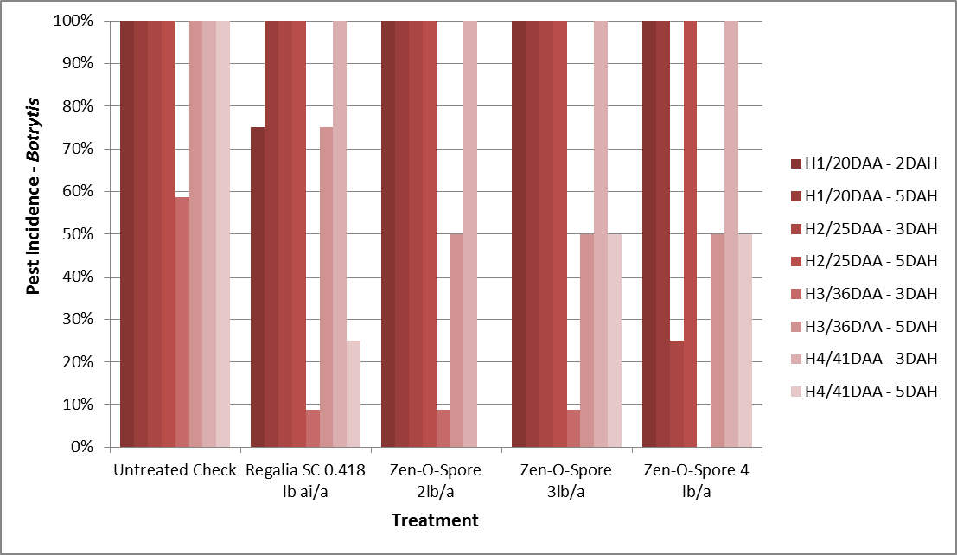

**Chart 1. *Botrytis* Incidence.** Average percentage of pest incidence for each treatment at 4 harvests, 2-5 days post-harvest rating.

**Table 2. *Rhizopus* Incidence.** Average percentage of pest incidence for each treatment at 4 harvests, 2-5 days post-harvest rating.



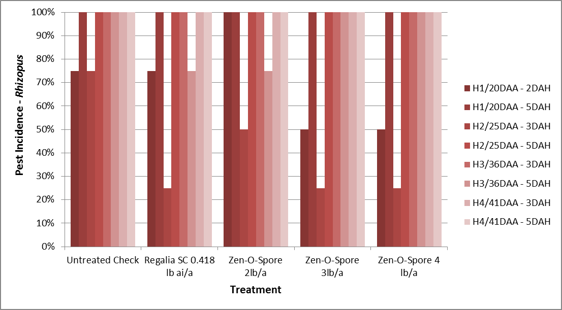

**Chart 2. *Rhizopus* Incidence.** Average percentage of pest incidence for each treatment at 4 harvests, 2-5 days post-harvest rating.

**Table 3. Other disease Incidence.** Average percentage of pest incidence for each treatment at 4 harvests, 2-5 days post-harvest rating.



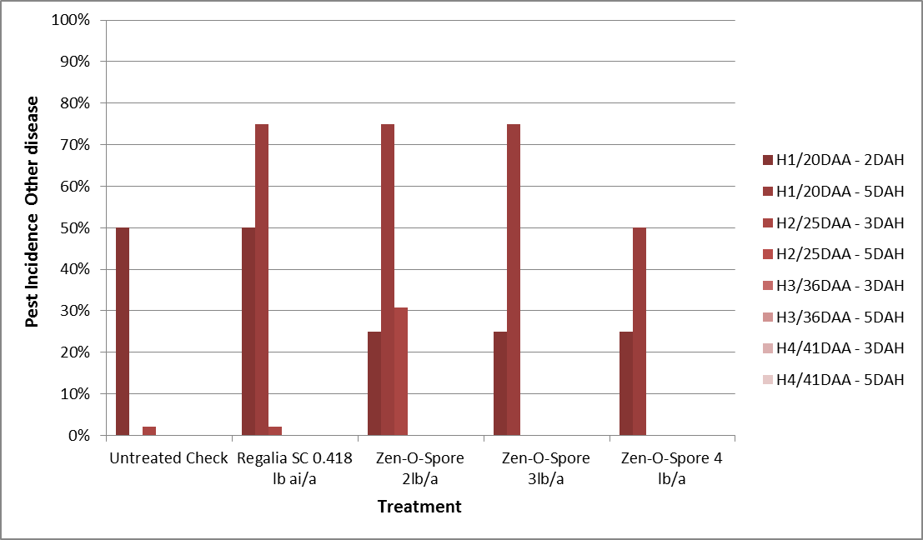

**Chart 3. Other disease Incidence.** Average percentage of pest incidence for each treatment at 4 harvests, 2-5 days post-harvest rating.

**Table 4. AUDPC.**  Average Area Under the Disease Progress Curve of post-harvest disease ratings for *Botrytis*, *Rhizopus* and other Diseases.



Note: AUDPC calculates the average disease intensity between each pair of adjacent time points. It is calculated by determining the average distance in rise of disease intensity for each evaluation date and adding them together by treatment.

$$\sum_{t=1}^{Νi-1}{\frac{y_{i}-y_{i-1}}{2}}(t_{i}-t_{1-1})$$

Where y = severity, t=time, N=average disease intensity between two adjacent time points.

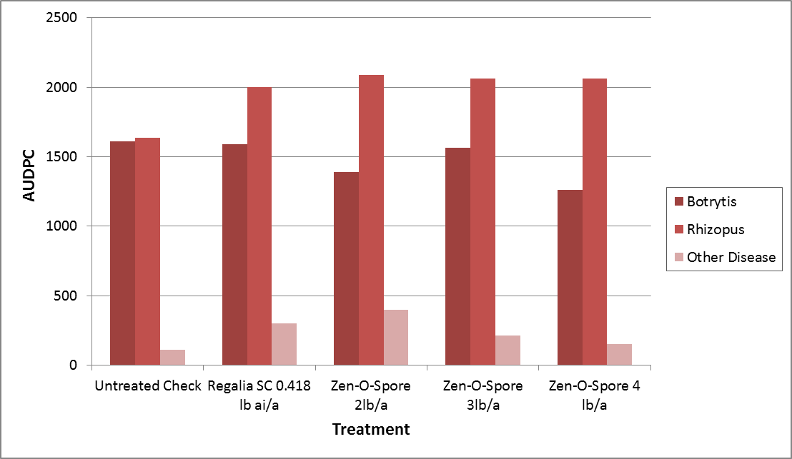

**Chart 4. AUDPC.**  Average Area Under the Disease Progress Curve of post-harvest disease ratings for *Botrytis*, *Rhizopus* and other Diseases.

**Table 5. % Control AUDPC.**  Control of post-harvest disease ratings for *Botrytis*, *Rhizopus* and other Diseases.



Note: This percent control expresses the severity of Fungal Disease infection in treated plots, compared to plants in the untreated check. It was calculated using the Abbott formula.

|  |  |  |  |  |  |
| --- | --- | --- | --- | --- | --- |
| Corrected % = (1 - | |  | | --- | | n in T after treatment | | http://www.ehabsoft.com/ldpline/line.gif | | n in Co after treatment | | ) * 100 |

Where: n = disease pressure, T = treated, Co = control

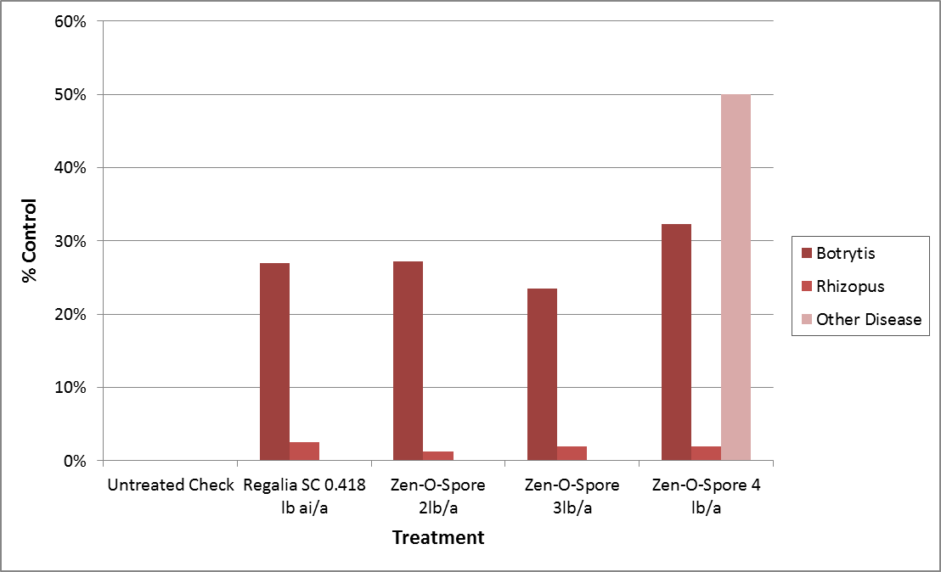

**Chart 5. % Control AUDPC.**  Control of post-harvest disease ratings for *Botrytis*, *Rhizopus* and other Diseases.

**Table 6. *Botrytis* –infected Berries.**  Count of post-harvest berries infected with *Botrytis*. Key: Harvest/Days After App – *n* Days After Harvest.



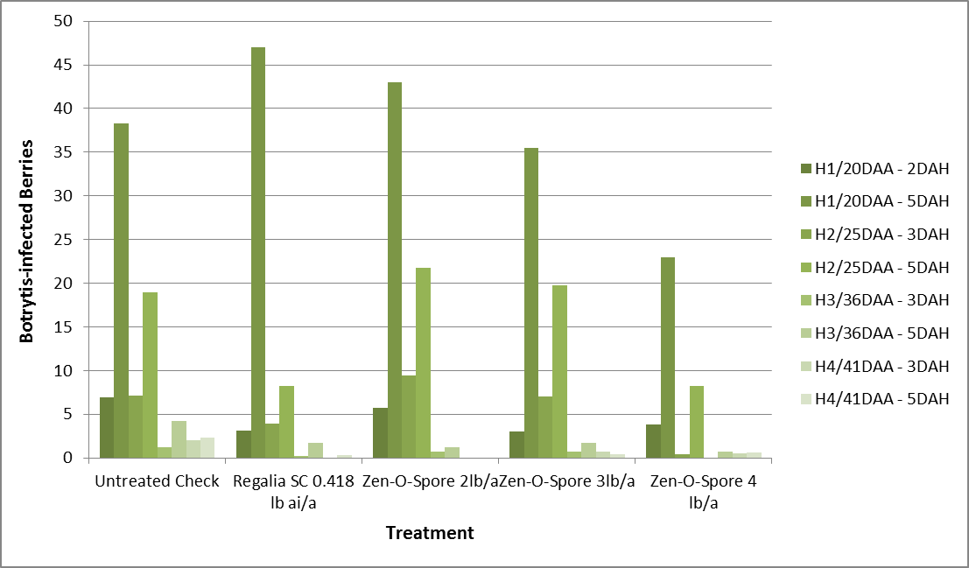

**Chart 6. *Botrytis* –infected Berries.**  Count of post-harvest berries infected with *Botrytis*. Key: Harvest/Days After App – *n* Days After Harvest.

**Table 7. *Rhizopus* –infected Berries.**  Count of post-harvest berries infected with *Rhizopus*. Key: Harvest/Days After App – *n* Days After Harvest.



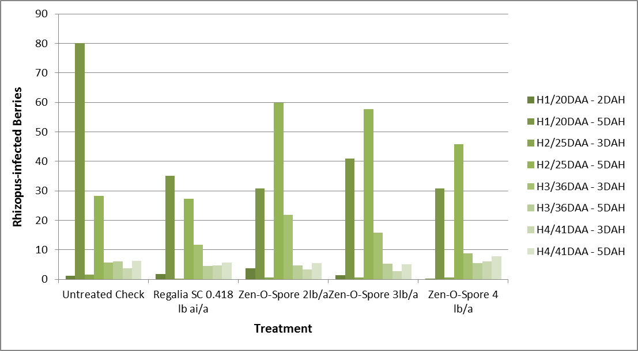

**Chart 7. *Rhizopus* –infected Berries.**  Count of post-harvest berries infected with *Rhizopus*. Key: Harvest/Days After App – *n* Days After Harvest.

**Table 8. Other disease –infected Berries.**  Count of post-harvest berries infected with other diseases. Key: Harvest/Days After App – *n* Days After Harvest.



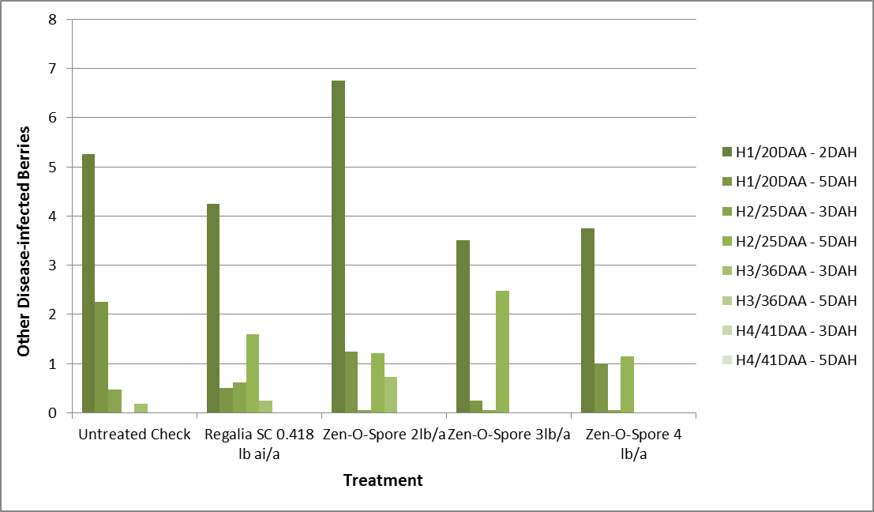

**Chart 8. Other disease –infected Berries.**  Count of post-harvest berries infected with other diseases. Key: Harvest/Days After App – *n* Days After Harvest.

**Table 9. Number Marketable Berries.**  Average count of marketable berries.



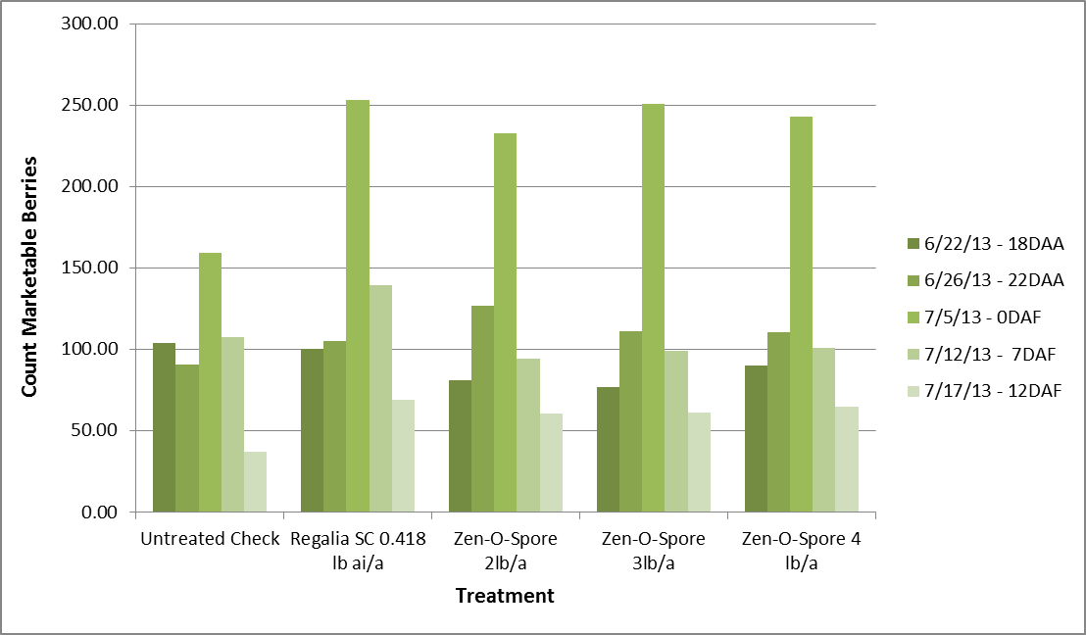

**Chart 9. Number Marketable Berries.**  Average count of marketable berries.

**Table 10. Weight Marketable Berries.**  Average weight (lb) of marketable berries.



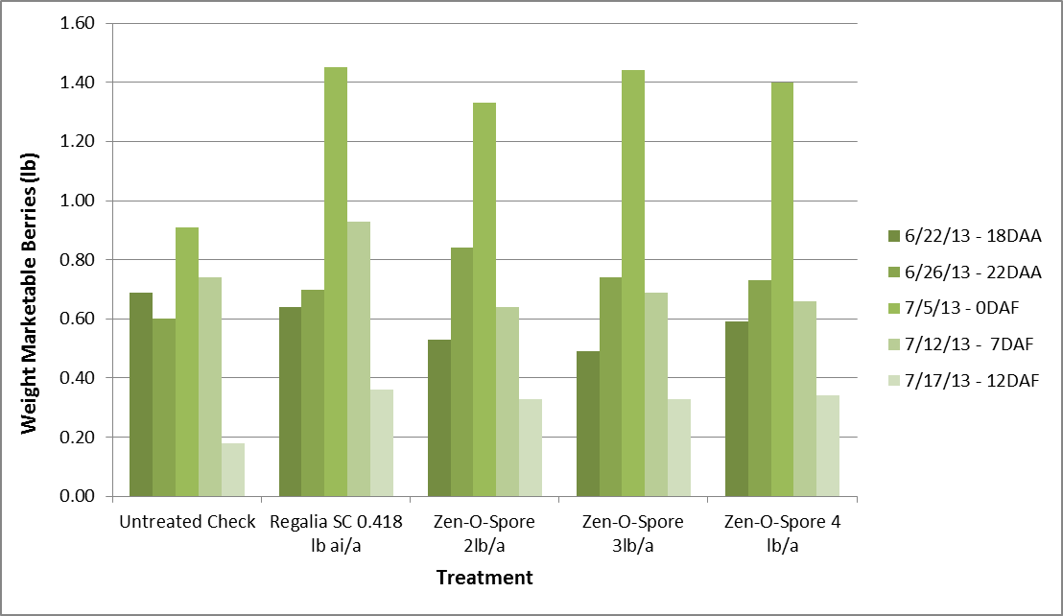

**Chart 10. Weight Marketable Berries.**  Average weight (lb) of marketable berries.

**Table 11. Count Unmarketable Berries.**  Average count of unmarketable (blemished, non-*Rhizopus* or non-*Botrytis* disease damages).



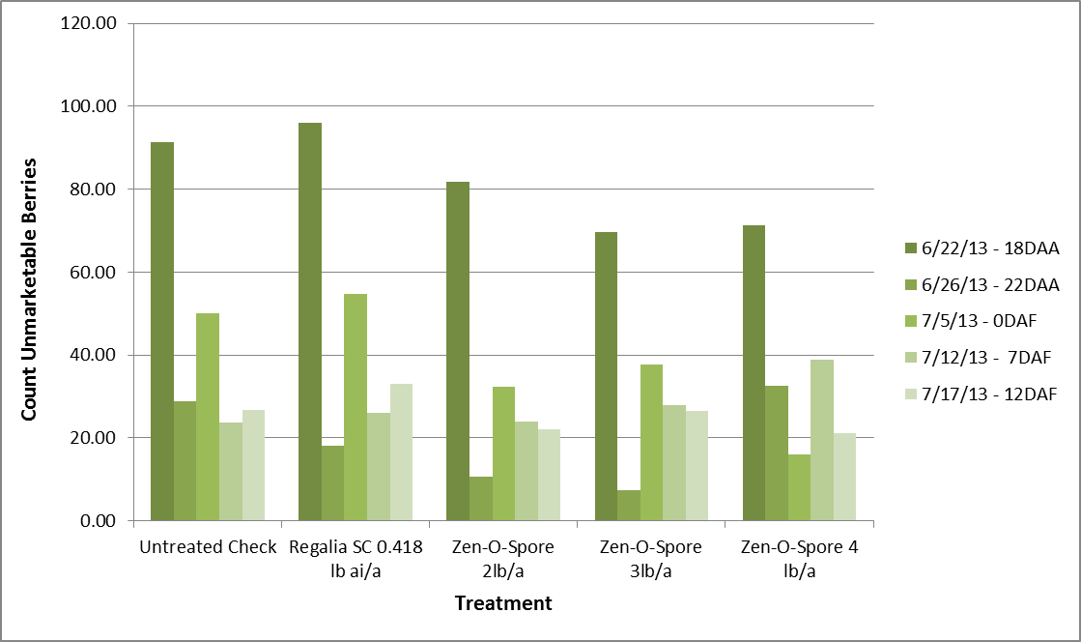

**Chart 11. Count Unmarketable Berries.**  Average count of unmarketable (blemished, non-*Rhizopus* or non-*Botrytis* disease damages).

**Table 12. Weight Unmarketable Berries.**  Average weight (lb) of unmarketable (blemished, non-*Rhizopus* or non-*Botrytis* disease damages).



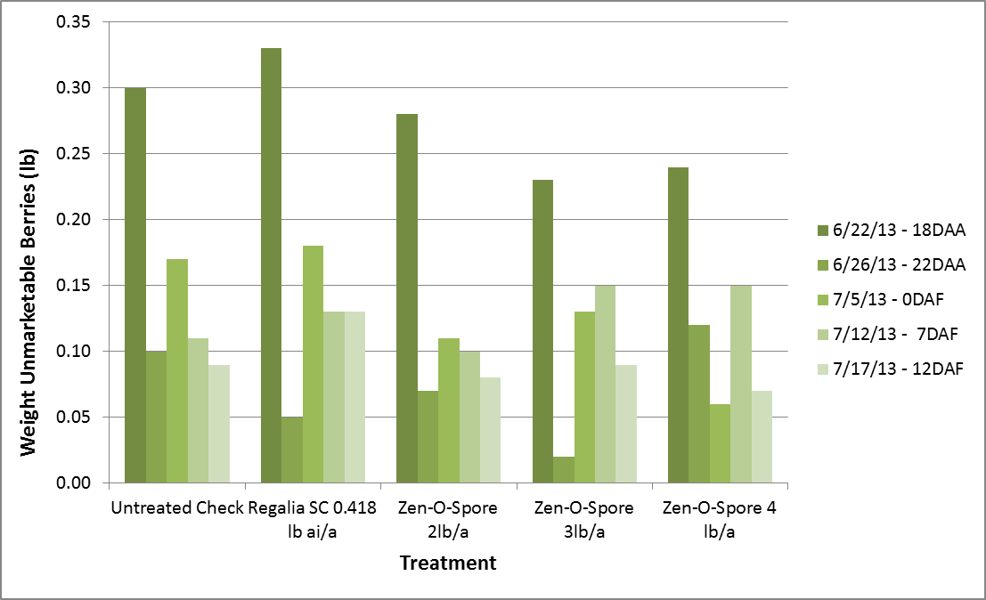

**Chart 12. Weight Unmarketable Berries.**  Average weight (lb) of unmarketable (blemished, non-*Rhizopus* or non-*Botrytis* disease damages).

**Table 13. Count *Botrytis*-infected Berries.**  Average count of *Botrytis* disease damaged berries.



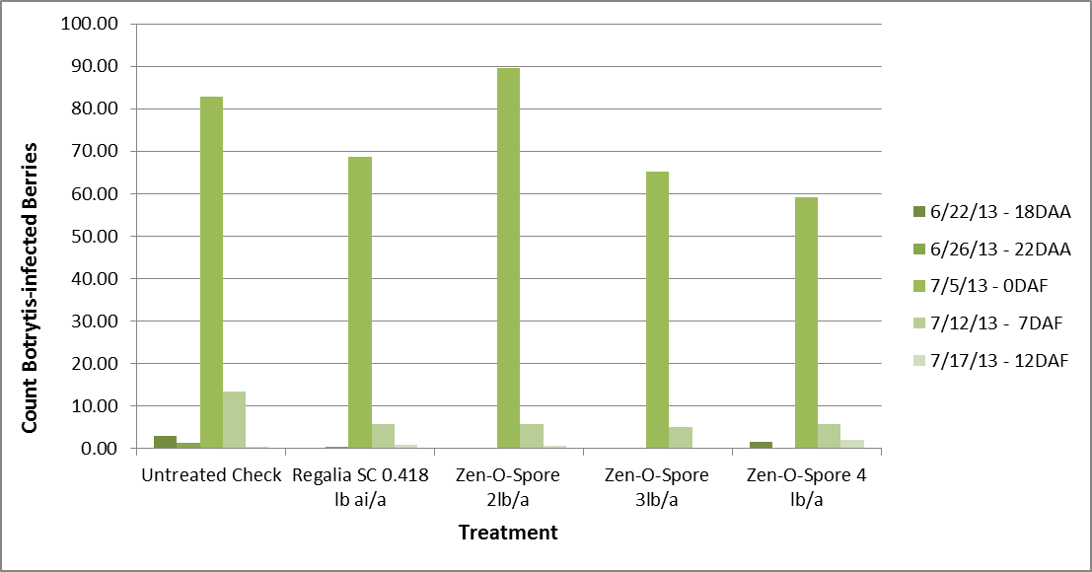

**Chart 13. Count *Botrytis*-infected Berries.**  Average count of *Botrytis* disease damaged berries.

**Table 14. Weight *Botrytis*-infected Berries.**  Average weight (lb) of *Botrytis* disease damaged berries.



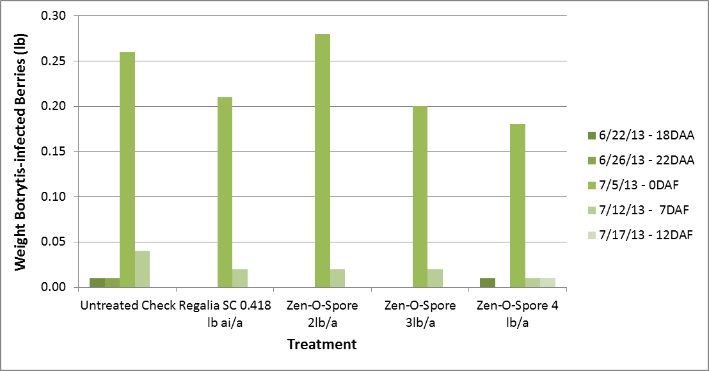

**Chart 14. Weight *Botrytis*-infected Berries.**  Average weight (lb) of *Botrytis* disease damaged berries.

**Table 15. Total Fruit Counts.**  Average total counts of total marketable, Unmarketable and Botrytis-infected berries.



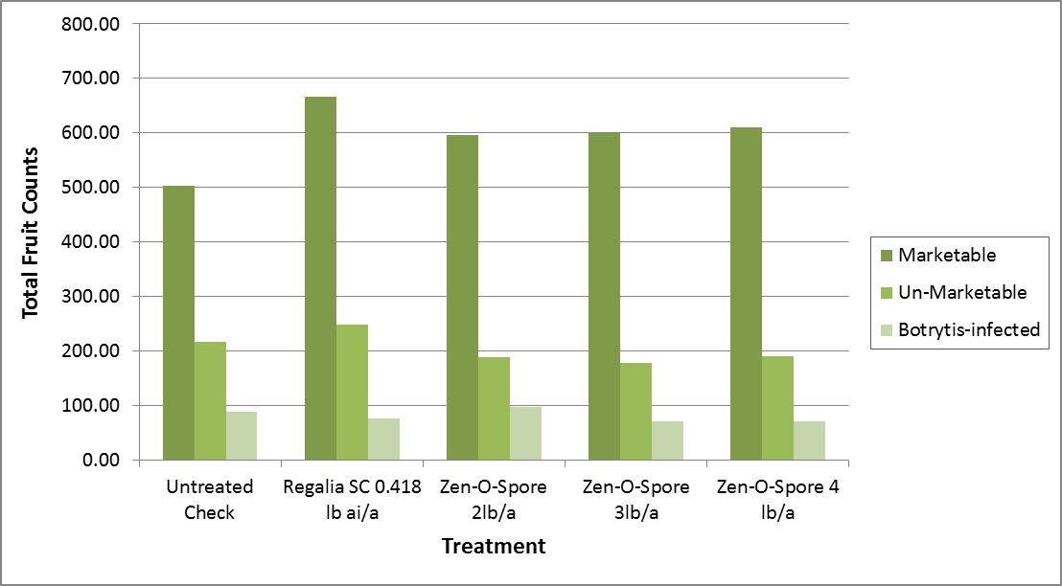

**Chart 15. Total Fruit Counts.**  Average total counts of total marketable, Unmarketable and Botrytis-infected berries.

**Table 16. Total Fruit Weight.**  Average total weight (lb) of total marketable, Unmarketable and Botrytis-infected berries.



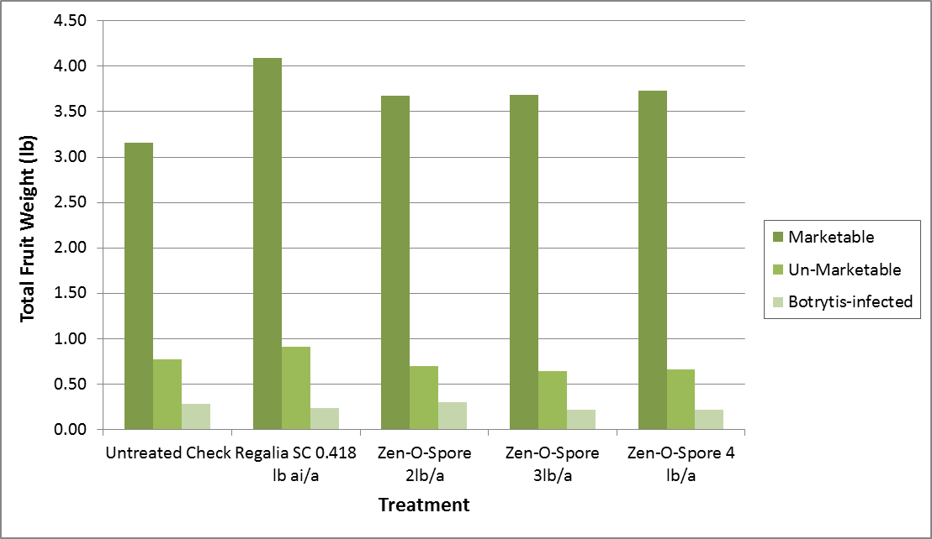

**Chart 16. Total Fruit Weight.**  Average total weight (lb) of total marketable, Unmarketable and Botrytis-infected berries.

**Table 17. Gross Yield.**  Yield of total marketable fruit per acre in pounds.



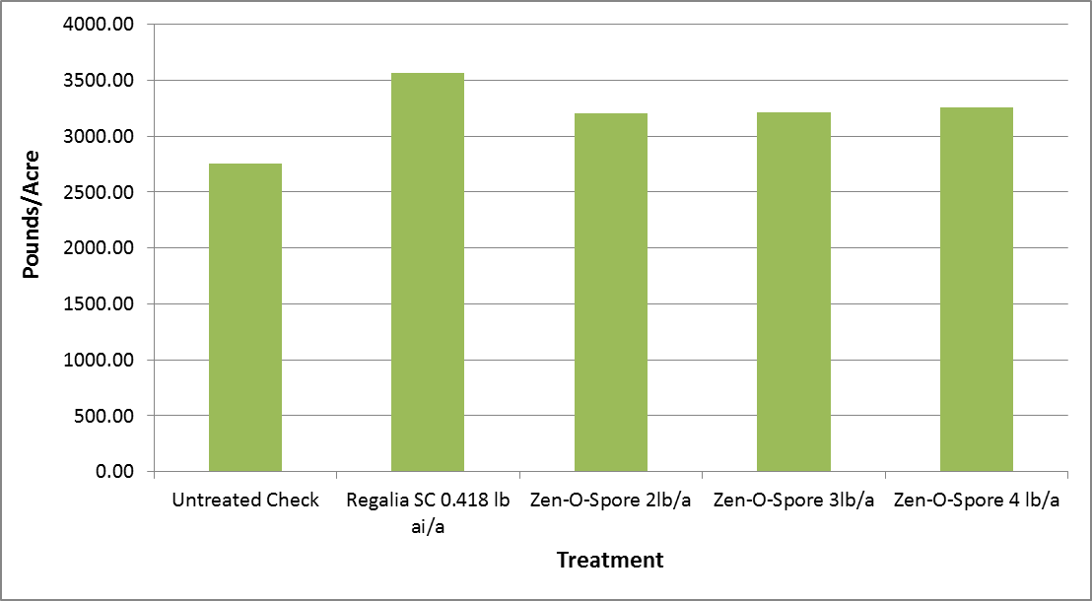

**Chart 17. Gross Yield**  Yield of total marketable fruit per acre in pounds.

**Table 18. Gross Return.**  Yield of total marketable fruit per acre in dollars at a rate of $1.50 per pound for fresh strawberries during the week of July 8th according to www.thepacker.com/commodity-fruits/strawberries.



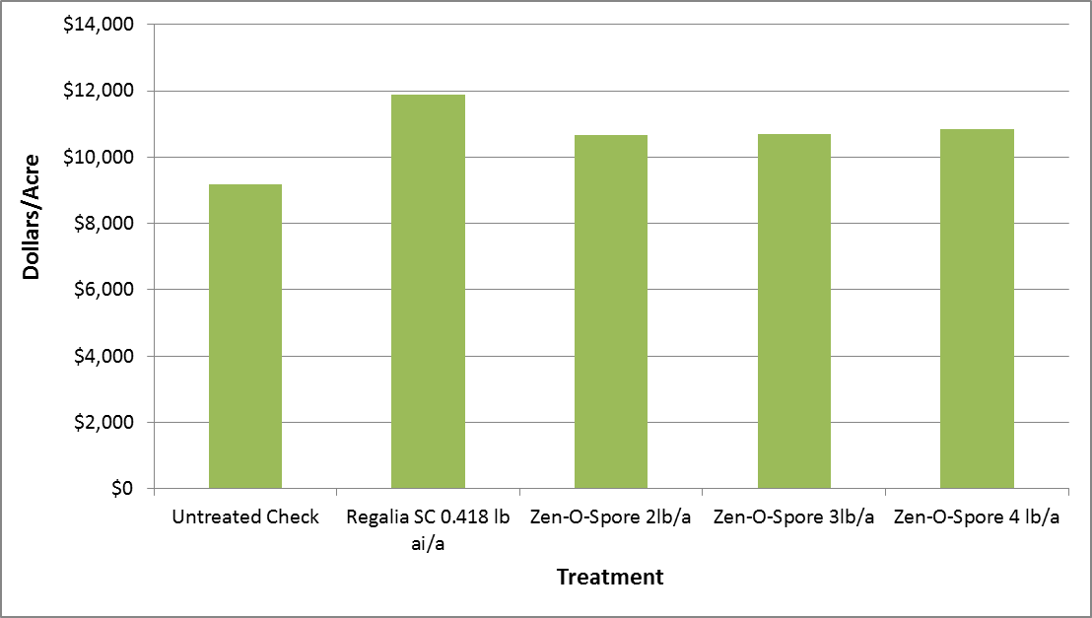

**Chart 18. Gross Return.**  Yield of total marketable fruit per acre in dollars at a rate of $1.50 per pound for fresh strawberries during the week of July 8th according to www.thepacker.com/commodity-fruits/strawberries.

**Table 19. Phytotoxicity.**  Crop damage due to chemical application at four rating times on a 0-10 scale (0 being no damage, 10 being dead).



CROP INFORMATION SHEET

|  |  |  |  |
| --- | --- | --- | --- |
| Principle Investigator: | Kevin Coons | Location: | Guadalupe Block A |
|  |  |  |  |
| Study Director: | Ewing & Associates | Grower: | Pacific Ag Research |
|  |  |  |  |
| Crop: | Raspberry | Date/Duration: | 6 Weeks |
|  |  |  |  |
| Test Products: | Zen-O-Spore | Planting Method: | Hand |
|  |  |  |  |
| Pest Species: | *Botrytis cinerea* | Harvest Method: | Hand |
|  |  |  |  |
|  |  | Adjuvants: | NuFilm/Spreader |
| Objective: | Efficacy for control of B*otrytis* in raspberry |  |  |
|  | Application Method: | Backpack CO2 |
|  |  |  |
|  | Calibration Method: | Timed Recapture |
|  |  |  |  |
| Plot Dimensions: | 3.33' x 15' | Nozzle Type: | FullCone T6 |
|  |  |  |  |
| Experiment Size: | 0.02 Ac | Nozzle Height: | 36" |
|  |  |  |  |
| Planting Density: | 22000 | Operating Pressure: | 50 PSI |
|  |  |  |  |
| Row Spacing: | 3.33' | Spray Boom Width: | 6" |
|  |  |  |  |
| No. Treatments/Reps: | 5 treat/4 rep | Dilution: | 75GPA |
|  |  |  |  |
|  |  | Irrigation Method: | Drip |
| Statistical Design: | RCB |  |  |
|  |  | Application Dates: | 6/14, 7/2 |
| No. Applications: | 2 |  |  |
|  |  |  | 6/7, 6/14, 6/21, 6/28, 7/1 |
| Appl. Frequency: | 5 weeks | Evaluation Dates: | 7/8, 7/10, 7/15, 7/17/2013 |

TREATMENT LIST



PLOT MAP



APPENDIX A: SOIL CHARACTERISTICS

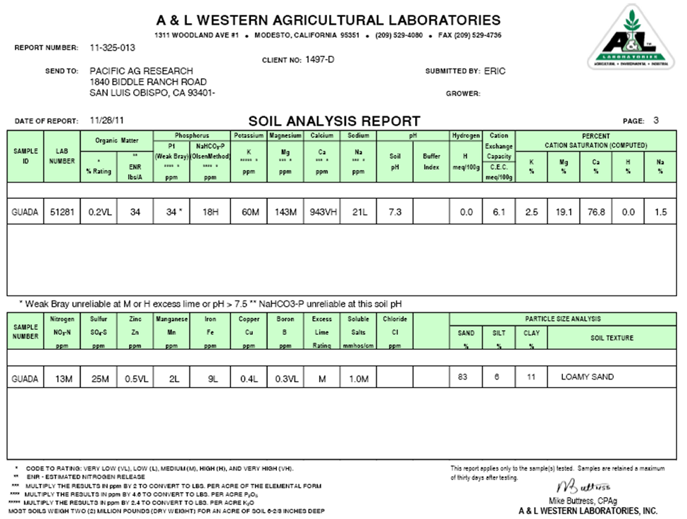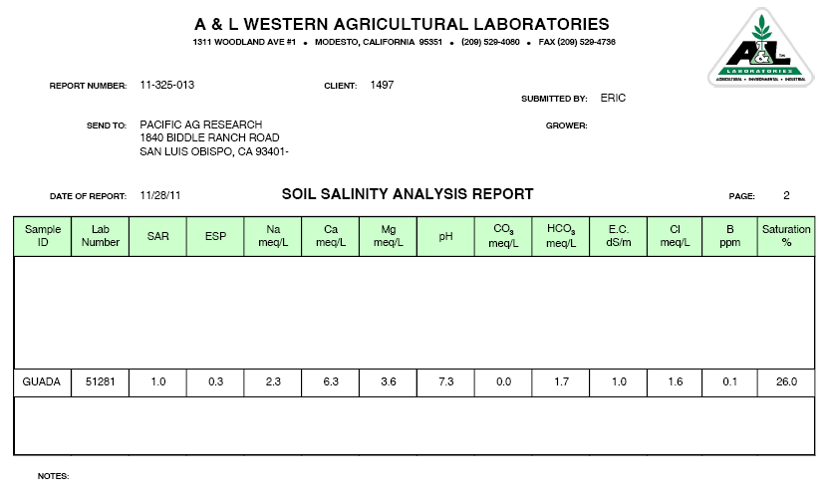

APPENDIX B: DAILY METEROLOGICAL SUMMARY:

GUADALUPE, CA

|  |  |  |  |  |  |  |
| --- | --- | --- | --- | --- | --- | --- |
| **Date** | **Precip (in)** | **Cumulative Rainfall** | **Max (F°)** | **Min (F°)** | **Mean (F°)** | **Rel Hum%** |
| 20-May-13 | 0.00 | 0.00 | 76.7 | 39.3 | 55.5 | 35.0 |
| 21-May-13 | 0.00 | 0.00 | 71.8 | 42.3 | 54.4 | 34.0 |
| 22-May-13 | 0.16 | 0.16 | 63.5 | 36.9 | 50.5 | 36.0 |
| 23-May-13 | 0.08 | 0.24 | 60.1 | 34.6 | 48.4 | 31.0 |
| 24-May-13 | 0.00 | 0.24 | 70.4 | 34.6 | 50.2 | 34.0 |
| 25-May-13 | 0.00 | 0.24 | 66.3 | 39.3 | 50.8 | 36.0 |
| 26-May-13 | 0.00 | 0.24 | 64.2 | 43.7 | 55.2 | 35.0 |
| 27-May-13 | 0.12 | 0.36 | 68.4 | 47.4 | 57.0 | 39.0 |
| 28-May-13 | 0.08 | 0.44 | 67.7 | 45.9 | 57.1 | 35.0 |
| 29-May-13 | 0.07 | 0.51 | 68.4 | 45.9 | 55.9 | 34.0 |
| 30-May-13 | 0.00 | 0.51 | 64.9 | 44.5 | 54.7 | 32.0 |
| 31-May-13 | 0.00 | 0.51 | 72.5 | 40.0 | 55.2 | 29.0 |
| 1-Jun-13 | 0.00 | 0.51 | 68.4 | 40.8 | 55.0 | 32.0 |
| 2-Jun-13 | 0.00 | 0.51 | 65.6 | 47.4 | 55.8 | 34.0 |
| 3-Jun-13 | 0.01 | 0.52 | 65.6 | 49.6 | 56.5 | 45.0 |
| 4-Jun-13 | 0.00 | 0.52 | 65.6 | 47.4 | 57.1 | 38.0 |
| 5-Jun-13 | 0.00 | 0.52 | 67.7 | 44.5 | 55.5 | 36.0 |
| 6-Jun-13 | 0.00 | 0.52 | 63.5 | 48.1 | 55.6 | 42.0 |
| 7-Jun-13 | 0.00 | 0.52 | 67.0 | 51.7 | 56.8 | 43.0 |
| 8-Jun-13 | 0.00 | 0.52 | 69.7 | 51.7 | 58.1 | 42.0 |
| 9-Jun-13 | 0.01 | 0.53 | 67.0 | 55.2 | 59.8 | 44.0 |
| 10-Jun-13 | 0.00 | 0.53 | 73.9 | 52.4 | 61.9 | 33.0 |
| 11-Jun-13 | 0.00 | 0.53 | 71.8 | 50.3 | 58.6 | 37.0 |
| 12-Jun-13 | 0.00 | 0.53 | 67.7 | 51.7 | 57.8 | 41.0 |
| 13-Jun-13 | 0.00 | 0.53 | 66.3 | 48.1 | 57.7 | 34.0 |
| 14-Jun-13 | 0.00 | 0.53 | 69.0 | 41.5 | 55.8 | 37.0 |
| 15-Jun-13 | 0.00 | 0.53 | 65.6 | 48.1 | 55.5 | 38.0 |
| 16-Jun-13 | 0.00 | 0.53 | 66.3 | 46.7 | 56.8 | 34.0 |
| 17-Jun-13 | 0.01 | 0.54 | 64.2 | 46.7 | 55.9 | 35.0 |
| 18-Jun-13 | 0.05 | 0.59 | 66.3 | 45.2 | 55.5 | 36.0 |
| 19-Jun-13 | 0.01 | 0.60 | 69.7 | 43.7 | 57.5 | 30.0 |
| 20-Jun-13 | 0.00 | 0.60 | 67.7 | 45.9 | 56.0 | 30.0 |
| 21-Jun-13 | 0.00 | 0.60 | 65.6 | 43.0 | 54.6 | 32.0 |
| 22-Jun-13 | 0.00 | 0.60 | 65.6 | 43.0 | 54.9 | 34.0 |

|  |  |  |  |  |  |  |
| --- | --- | --- | --- | --- | --- | --- |
| **Date** | **Precip (in)** | **Cumulative Rainfall** | **Max (F°)** | **Min (F°)** | **Mean (F°)** | **Rel Hum%** |
| 23-Jun-13 | 0.00 | 0.60 | 66.3 | 49.6 | 57.1 | 38.0 |
| 24-Jun-13 | 0.01 | 0.61 | 76.7 | 54.5 | 63.5 | 44.0 |
| 25-Jun-13 | 0.00 | 0.61 | 70.4 | 55.9 | 63.2 | 49.0 |
| 26-Jun-13 | 0.00 | 0.61 | 73.2 | 53.8 | 63.3 | 46.0 |
| 27-Jun-13 | 0.00 | 0.61 | 78.8 | 53.1 | 63.8 | 42.0 |
| 28-Jun-13 | 0.00 | 0.61 | 74.6 | 52.4 | 61.1 | 36.0 |
| 29-Jun-13 | 0.00 | 0.61 | 79.5 | 51.0 | 63.9 | 31.0 |
| 30-Jun-13 | 0.00 | 0.61 | 71.8 | 51.0 | 60.4 | 34.0 |
| 1-Jul-13 | 0.00 | 0.61 | 75.3 | 51.7 | 62.6 | 36 |
| 2-Jul-13 | 0.00 | 0.61 | 88.8 | 54.5 | 65.4 | 38 |
| 3-Jul-13 | 0.00 | 0.61 | 75.3 | 51.7 | 60.9 | 47 |
| 4-Jul-13 | 0.00 | 0.61 | 71.1 | 53.1 | 61.3 | 49 |
| 5-Jul-13 | 0.00 | 0.61 | 69.0 | 54.5 | 60.0 | 47 |
| 6-Jul-13 | 0.00 | 0.61 | 67.7 | 51.7 | 58.4 | 39 |
| 7-Jul-13 | 0.00 | 0.61 | 67.7 | 48.8 | 58.4 | 39 |
| 8-Jul-13 | 0.00 | 0.61 | 69.7 | 53.8 | 60.0 | 51 |
| 9-Jul-13 | 0.00 | 0.61 | 68.4 | 52.4 | 58.8 | 43 |
| 10-Jul-13 | 0.00 | 0.61 | 67.7 | 53.1 | 58.6 | 47 |
| 11-Jul-13 | 0.00 | 0.61 | 69.7 | 53.1 | 59.9 | 43 |
| 12-Jul-13 | 0.00 | 0.61 | 67.0 | 52.4 | 58.4 | 43 |
| 13-Jul-13 | 0.00 | 0.61 | 70.4 | 52.4 | 58.9 | 51 |
| 14-Jul-13 | 0.00 | 0.61 | 67.0 | 51.7 | 57.9 | 46 |
| 15-Jul-13 | 0.00 | 0.61 | 67.0 | 49.6 | 57.1 | 42 |
| 16-Jul-13 | 0.00 | 0.61 | 68.4 | 48.1 | 58.3 | 38 |
| 17-Jul-13 | 0.00 | 0.61 | 67.7 | 46.7 | 57.5 | 39 |
| 18-Jul-13 | 0.00 | 0.61 | 66.3 | 49.6 | 57.5 | 41 |
| 19-Jul-13 | 0.00 | 0.61 | 65.6 | 51.0 | 56.3 | 43 |
| 20-Jul-13 | 0.00 | 0.61 | 67.7 | 51.7 | 57.1 | 40 |
| 21-Jul-13 | 0.00 | 0.61 | 69.7 | 51.7 | 59.7 | 39 |
| 22-Jul-13 | 0.00 | 0.61 | 77.4 | 56.6 | 62.8 | 40 |
| 23-Jul-13 | 0.01 | 0.62 | 73.2 | 55.2 | 61.7 | 43 |
| 24-Jul-13 | 0.00 | 0.62 | 69.0 | 53.1 | 59.7 | 48 |
| 25-Jul-13 | 0.00 | 0.62 | 71.1 | 53.8 | 59.2 | 47 |
| 26-Jul-13 | 0.00 | 0.62 | 69.0 | 53.8 | 58.6 | 47 |
| 27-Jul-13 | 0.00 | 0.62 | 68.4 | 53.8 | 58.6 | 42 |
| 28-Jul-13 | 0.00 | 0.62 | 69.7 | 53.8 | 59.4 | 40 |
| 29-Jul-13 | 0.00 | 0.62 | 69.0 | 54.5 | 59.7 | 40 |
| 30-Jul-13 | 0.00 | 0.62 | 67.7 | 51.0 | 59.2 | 36 |
| 31-Jul-13 | 0.00 | 0.62 | 67.7 | 48.8 | 56.6 | 39 |

APPENDIX C: PHOTOGRAPHS

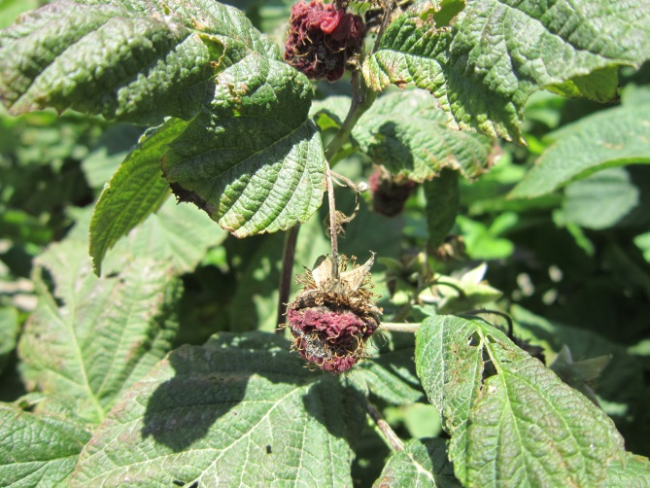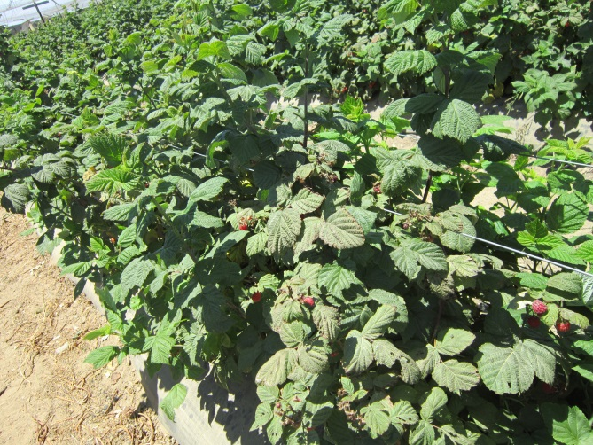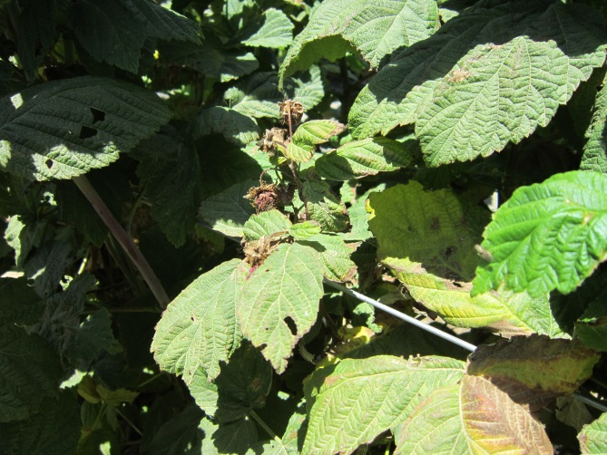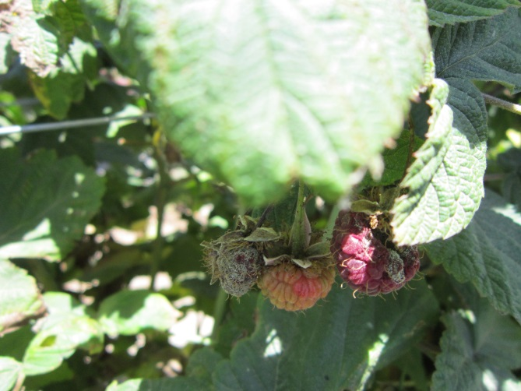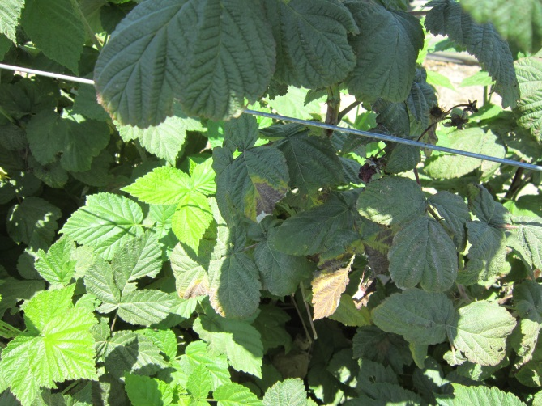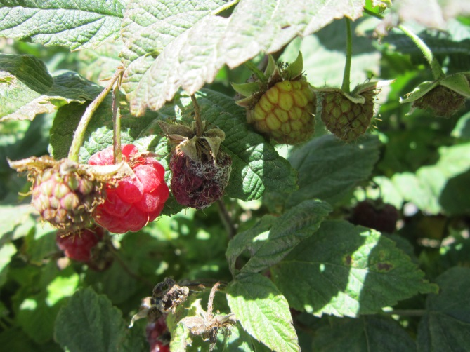

**Image 6**. Phytotoxicity, browning in field raspberry.

**Image 5**. Field raspberry.

**Image 4**. *Botrytis* in field.

**Image 3**. *Botrytis* in field.

**Image 2**. *Botrytis* in field.

**Image 1**. *Botrytis* in field.

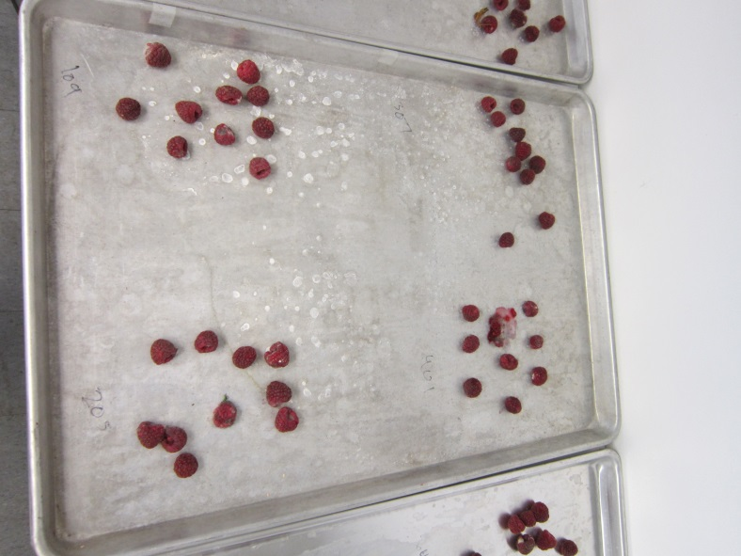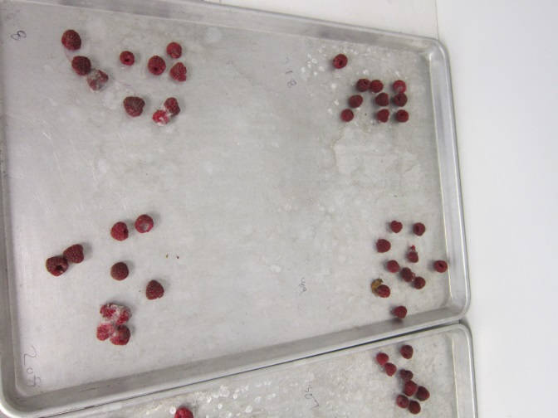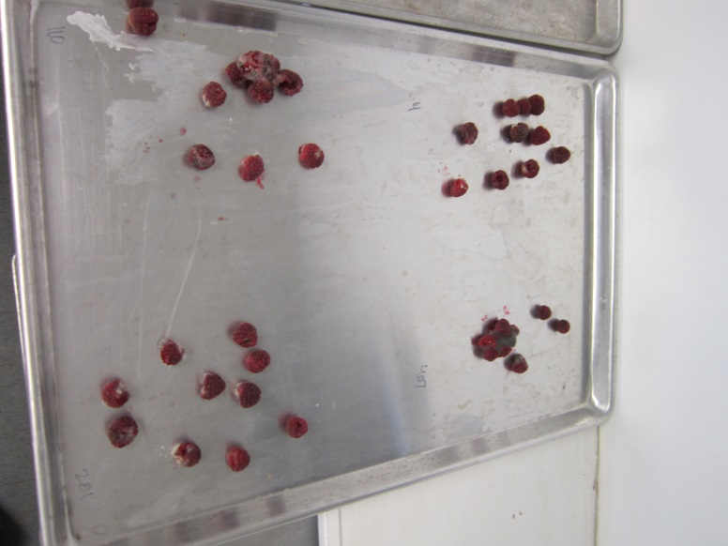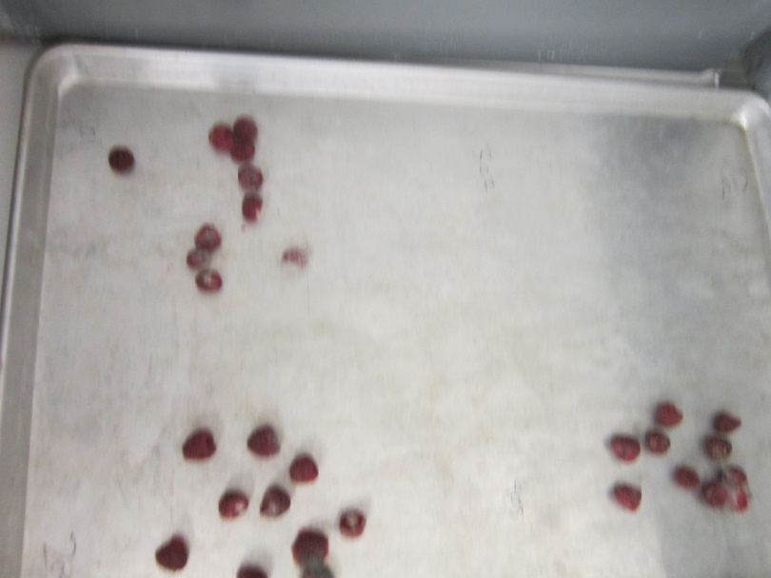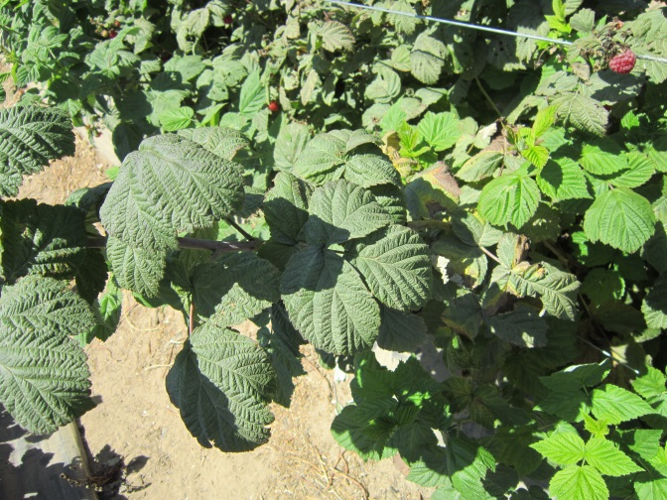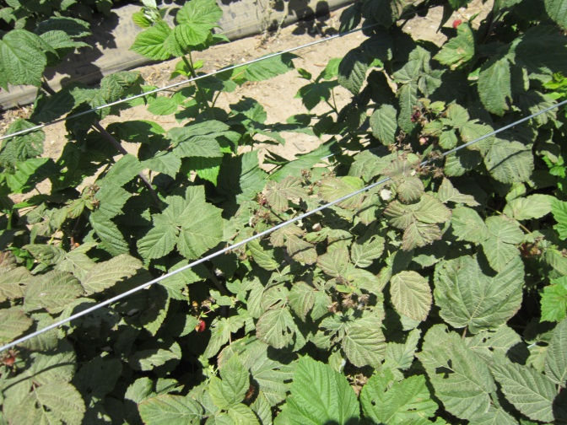

**Image 12**. 3DAH, treatment 5 – Zen-O-Spore 4 lb/a.

**Image 11**. 3DAH, treatment 4 – Zen-O-Spore 3 lb/a.

**Image 10**. 3DAH, treatment 3 – Zen-O-Spore 2 lb/a.

**Image 9**. 3DAH, treatment 1 – Untreated Check.

**Image 8**. Phytotoxicity.

**Image 7**. Phytotoxicity.

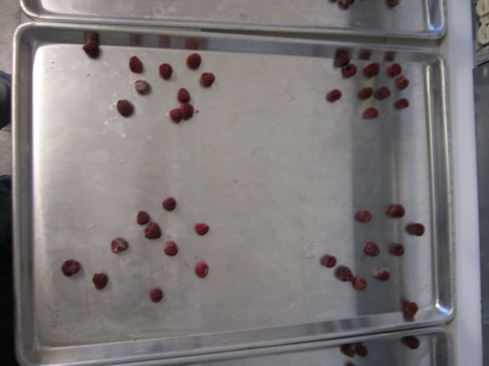

**Image 14**. 3DAH, treatment 2 – Regalia SC 0.418 lb ai/a.