RESEARCH AND DEVELOPMENT

PROJECT REPORT

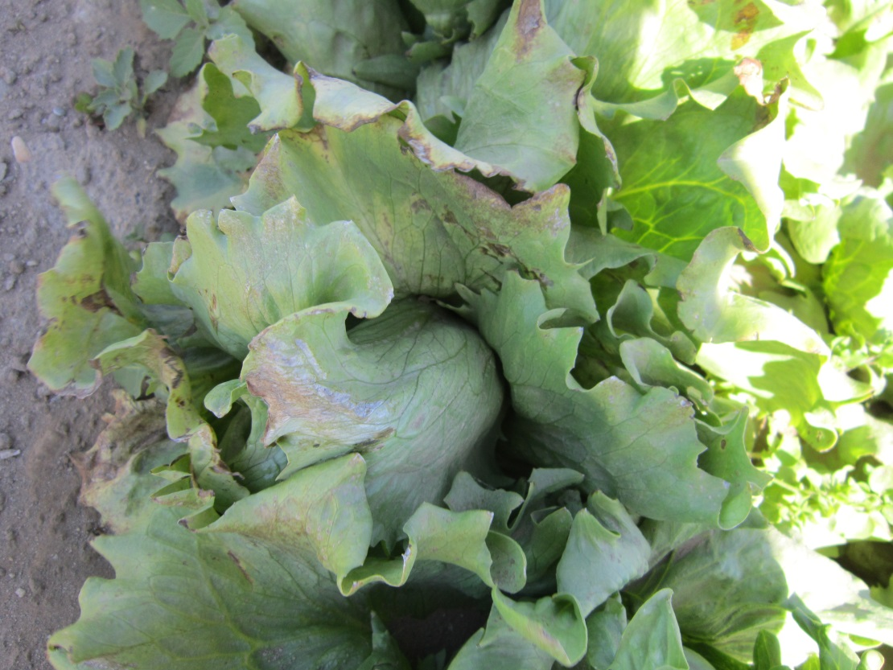

Efficacy of Armour-Zen for Control of *Bremia lactucae* (Downy Mildew) in Lettuce

**Trial ID:**

ENA1307

**Prepared for:**

Duane Ewing / Ewing & Associates

**Prepared by:**



Summer 2013

Table of Contents

ABSTRACT Page 3

MATERIALS AND METHODS Page 4

Treatments

Application Equipment

Evaluations

RESULTS

Table/Graph 1. Lesions/Head Page 5

Table/Graph 2. Pest Severity Page 6

Table/Graph 3. AUDPC- Severity Page 7

Table/Graph 4. % Control Page 8

CROP INFORMATION SHEET Page 9

TREATMENT LIST and PLOT MAP Page 10

APPENDIX A: DAILY METEROLOGICAL SUMMARY: GUADALUPE, CA Page 11

APPENDIX B: PHOTOGRAPHS Page 14

APPENDIX C: SOIL INFORMATION Page 16

ABSTRACT

Product(s) Tested: Armour-Zen

Crop: Lettuce, cv. Cannery Row

Location: Guadalupe, CA

Duration of Project: 5 weeks

Objective: Evaluate efficacy of Armour-Zen against downy mildew on lettuce in the Central Coast of California.

Findings:

* Counts of lesions per head were not significantly different between treatments but were consistently lower than in untreated check plots.
* Pest severity increased with increasing application rate of Armour-Zen. The 1 qt/100 gal rate had lower average severity ratings compared to the 2 or 3 qt/gal rate despite not being significantly different at p<0.05.

Narrative:

This study was conducted to evaluate the efficacy of the fungicide product Armour-Zen against *Bremia lactucae* (downy mildew) of lettuce. Treatments included a standard grower application of Reason at 7 fl oz/a plus adjuvant. Armour-Zen at rates of 1, 2 and 4 qt/100 gallons (plus adjuvant) and an untreated check were also applied. For the first application, the adjuvant Spreader 90 (8 fl oz/100 gal) was used, but for the remaining four applications the adjuvant Nu Film at 8 fl oz/a was used.

Applications were applied using a backpack CO2 sprayer repeated at 7-day intervals.

Lesions per head and pest severity were rated in the field every 5-8 days. Downy mildew incidence was nothing at trial outset but disease pressure increased as the experiment proceeded, with the average pest severity on untreated plants reaching 22%.

MATERIALS AND METHODS

*Treatments:*

This study consisted of 5 treatments applied April 30th (A), May 9th (B), May 17th (C), May 31st (D) and June 7th, 2013 (E).

1. Reason 7 fl oz/a (A-E) + Spreader 90 8 fl oz/100 gal (A) + Nu Film 8 fl oz/a (B-E)
2. Armour Zen 1 qt/100 gal (A-E) + Spreader 90 8 fl oz/100 gal (A) + Nu Film 8 fl oz/a (B-E)
3. Armour Zen 2 qt/100 gal (A-E) + Spreader 90 8 fl oz/100 gal (A) + Nu Film 8 fl oz/a (B-E)
4. Armour Zen 4 qt/ (A-E) + Spreader 90 8 fl oz/100 gal (A) + Nu Film 8 fl oz/a (B-E)
5. Untreated (A-E)

*Application Equipment:*

Forty gallons per acre of treatment applications were sprayed using a CO2 backpack sprayer with boom incorporating six full cone T6 0.5 nozzles operating at a pressure of 50 PSI. The diagram below illustrates the boom used.

36”

14”

*Evaluations:*

Seven evaluations were carried out: April 30th, May 8th, May 16th, May 22nd, May 29th, June 5th, June 12th, 2013. Assessments included number of lesions per plant and severity of infestation, heads. Statistics were analyzed using ANOVA mean comparison with Student-Newman-Keul’s test and α=0.05.

RESULTS

**Table 1**. **Lesions/Head**. Average number of lesions counted per head.



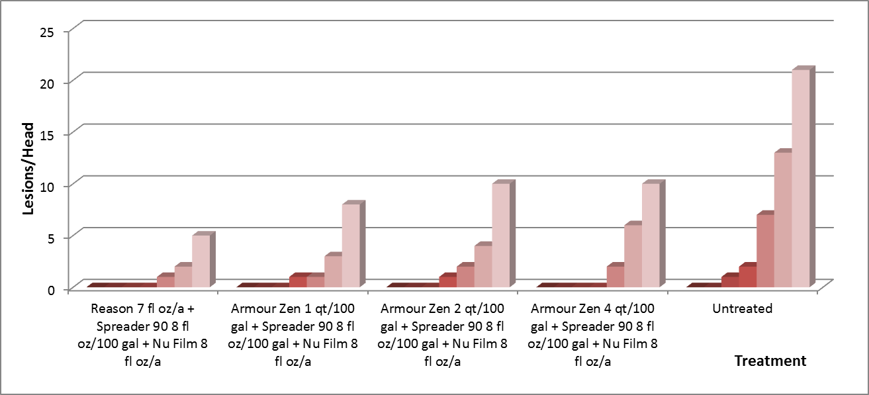

**Chart 1**. **Lesions/Head**. Average number of lesions counted per head.

RESULTS

**Table 2**. **Pest Severity**. Average severity of downy mildew on lettuce (0-100%).



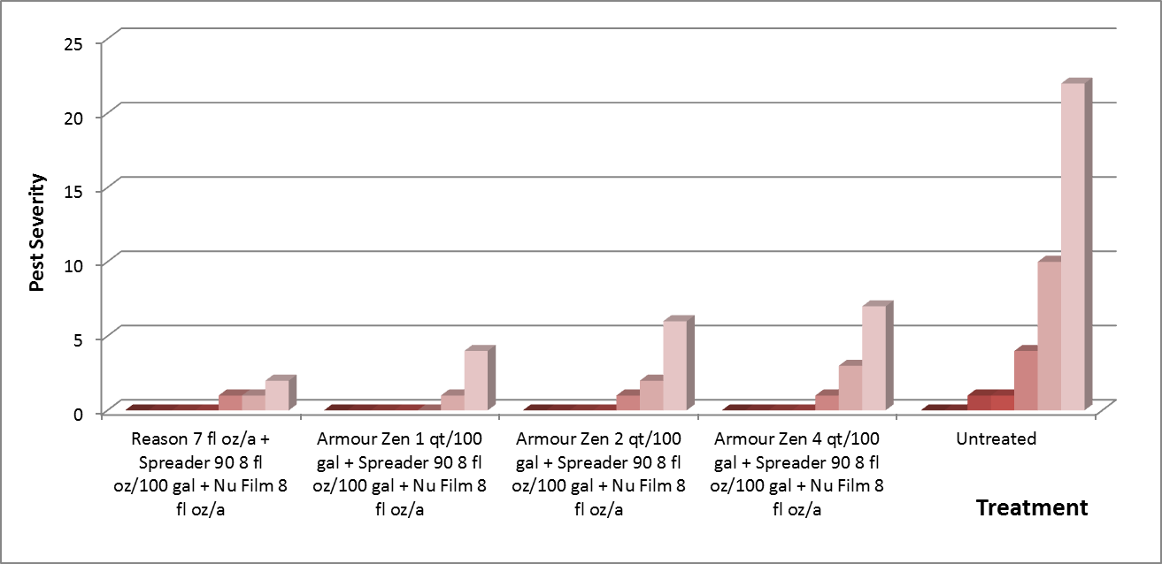

**Graph 2.** **Pest Severity**. Graphical representation of average severity of downy mildew on lettuce (0-100%).

RESULTS

**Table 7.**  **AUDPC- Severity**. Area under disease progress curve based on severity of downy mildew on lettuce.



AUDPC calculates the average disease severity between each pair of adjacent time points. It is calculated by determining the average distance in rise of disease intensity for each evaluation date and adding them together by treatment.

$$\sum_{t=1}^{Νi-1}{\frac{y_{i}-y_{i-1}}{2}}(t_{i}-t_{1-1})$$

where y = severity, t=time, N=average disease severity between two adjacent time points

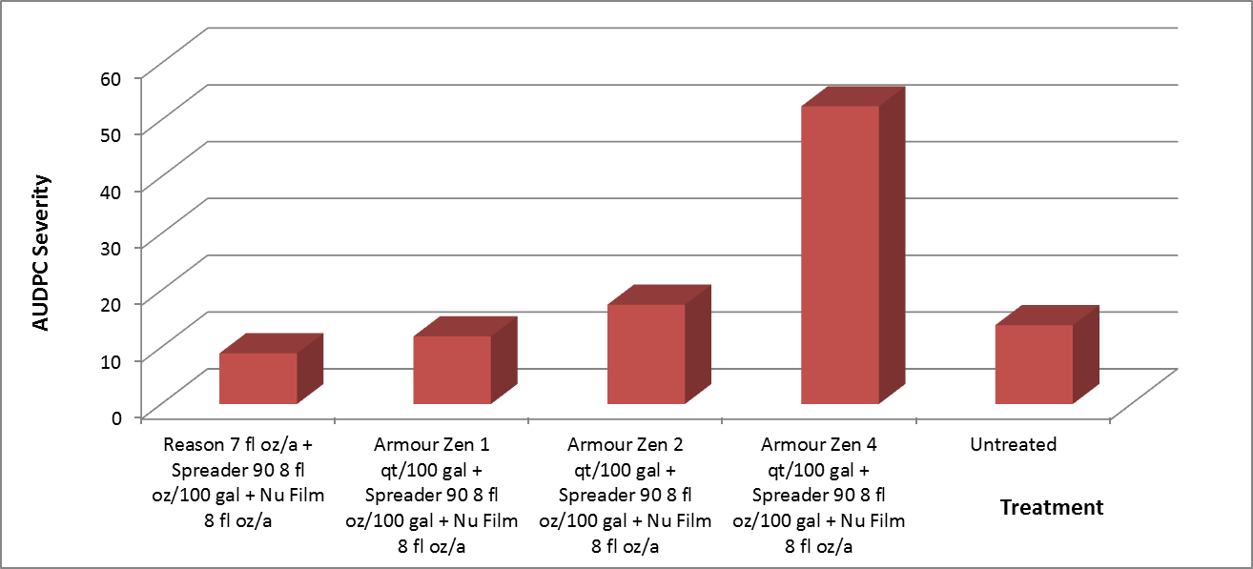

**Chart 7.**  **AUDPC- Severity**. Graphical representation of area under disease progress curve based on severity of downy mildew on lettuce.

RESULTS

**Table 8.**  **% Control** . Percent control of disease severity AUDPC.



Note: This percent control expresses the severity of Fungal Disease infection in treated plots, compared to plants in the untreated check. It was calculated using the Abbott formula.

|  |  |  |  |  |  |
| --- | --- | --- | --- | --- | --- |
| Corrected % = (1 - | |  | | --- | | n in T after treatment | | http://www.ehabsoft.com/ldpline/line.gif | | n in Co after treatment | | ) * 100 |

Where: n = disease pressure, T = treated, Co = control

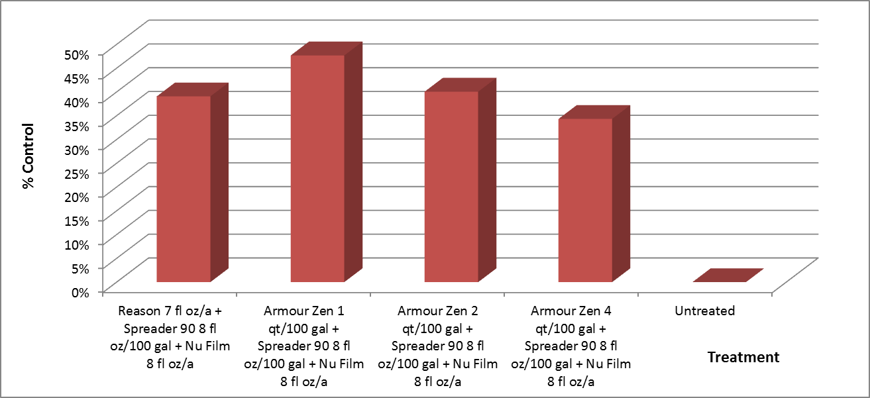

**Chart 8.**  **% Control** . Graphical representation of percent control of disease severity AUDPC.

CROP INFORMATION SHEET



TREATMENT LIST



PLOT MAP



APPENDIX A: DAILY METEROLOGICAL SUMMARY:

GUADALUPE, CA





APPENDIX B: PHOTOGRAPHS

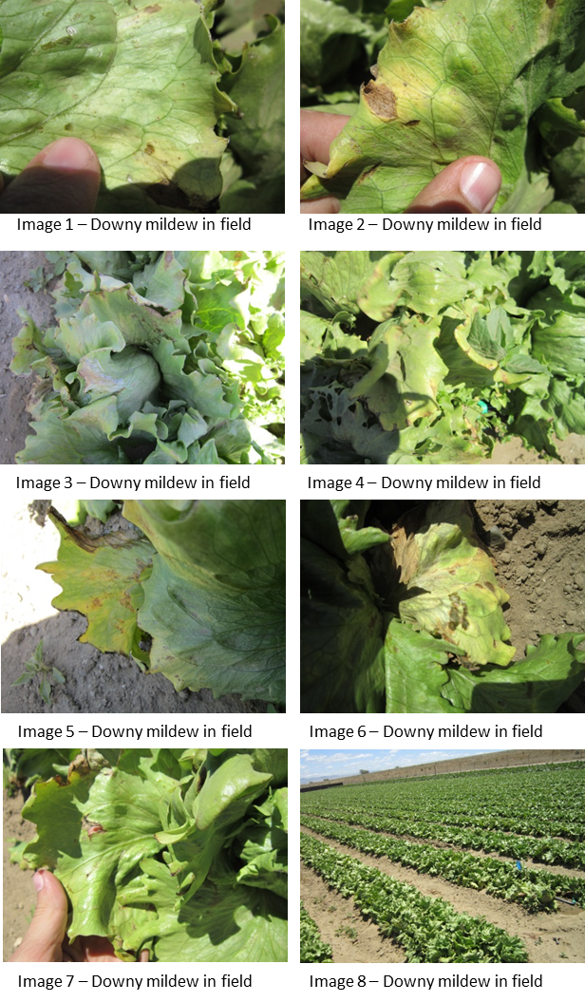

APPENDIX C: SOIL CHARACTERISTICS

