RESEARCH AND DEVELOPMENT

PROJECT REPORT

Efficacy for control of ARMOUR-Zen against Powdery Mildew in Squash

**Trial ID: ENA1315**

Guadalupe, CA – Pacific Ag Research Farm

**Prepared for:**

Duane Ewing / Ewing & Associates

**Prepared by:**

PAG logo2 no address.BMP

Summer 2013

Table of Contents

ABSTRACT Page 3

MATERIALS AND METHODS Page 4

Treatments

Experimental Unit

Application Equipment

Evaluations

RESULTS

Table/Chart 1. Severity – Powdery Mildew Page 6

Table/Chart 2. Incidence – Powdery Mildew Page 7

Table/Chart 3. AUDPC – Powdery Mildew Page 8

Table/Chart 4. Percent Control – Powdery Mildew Page 9

Table/Chart 5. Small Zucchini Weight (kg) Page 10

Table/Chart 6. Medium Zucchini Weight (kg) Page 11

Table/Chart 7. Large Zucchini Weight (kg) Page 12

Table/Chart 8. Extra-Large Zucchini Weight (kg) Page 13

Table/Chart 9. Total Yield (percent) Page 14

Table/Chart 10. Cartons/Acre Page 15

Table/Chart 11. Gross Returns Page 16

TREATMENT LIST and PLOT MAP Page 17

CROP INFORMATION Page 18

APPENDIX A: DAILY METEROLOGICAL SUMMARY: GUADALUPE, CA Page 19

APPENDIX B: SOIL ANALYSIS Page 23

ABSTRACT

*Objective:* Evaluate the efficacy of ARMOUR-Zen against Powdery Mildew in ‘Ambassador’ zucchini

*Product(s) tested:*  ARMOUR-Zen

*Location:* Guadalupe, CA – Pacific Ag Research Farm – Ranch 2

*Project Duration:* August - October, 2013

*Key Findings:*

* Clear positive dose response to Armour-Zen in powdery mildew severity and incidence
* Quadris had best performance in controlling pest severity
* Numerically, the 4 qt/Ac rate of Armour-Zen was superior to the 2 and 1 qt/Ac rates
* No significant differences in yield between treated and untreated plots

Narrative:

This trial was established in order to test efficacy of ARMOUR-Zen against powdery mildew in squash grown on California’s central coast.

Powdery mildew severity was always statistically higher in the untreated check plots five days after the fourth application and on. Following a clear dose response trend, the higher rates of ARMOUR-Zen had decreased pest severity, and, consequently, higher disease control. Percent control between ARMOUR-Zen treatments was numerically, but not statistically, different. Quadris Top at 14 fl oz/a has significantly superior to all products in controlling powdery mildew.

Yields were not significantly different between treated and untreated plots. Final gross returns were estimated to be as much as $5,963/acre (2 qt/ac rate of ARMOUR-Zen).

MATERIALS AND METHODS

*Treatments:*

This study consisted of five treatments, applied as foliar broadcast sprays beginning two weeks after thinning and applied on 7-10 day intervals; August 29 (A), September 5 (B), September 12 (C), September 19 (D) and September 29 (E).

1. Untreated
2. ARMOUR Zen 1 qt/100 gal (A-E) + Spreader 90 8 fl oz/100 gal (A-E)
3. ARMOUR Zen 2 qt/100 gal (A-E) + Spreader 90 8 fl oz/100 gal (A-E)
4. ARMOUR Zen 4 qt/100 gal (A-E) + Spreader 90 8 fl oz/100 gal (A-E)
5. Quadris Top 14 fl oz/a (A-E) + Spreader 90 8 fl oz/100 gal (A-E)

*Experimental Unit:*

The trial consisted of plots of 40’ lengths of 40”-wide rows of Ambassador variety green zucchini, hand transplanted at a rate of 13,081 plants/acre. Plants were spaced 24” apart. Treatments were replicated four times in a randomized complete block design. At application A, zucchini plants were an average of 13” tall, 25” tall for applications B-D, and 28” tall for the fifth and final application (E).

*Application Equipment:*

A backpack CO2 manual sprayer with 40”-wide boom incorporating seven TG-1 nozzles was used to apply treatments at the first application, at 50 gal/acre and a pressure of 30 psi. The boom for application B was 54 inches wide and incorporated seven TG-0.5 nozzles. The final three applications went out using a 52”-wide boom with eight TG-0.5 nozzles.

Boom diagrams below:

1. 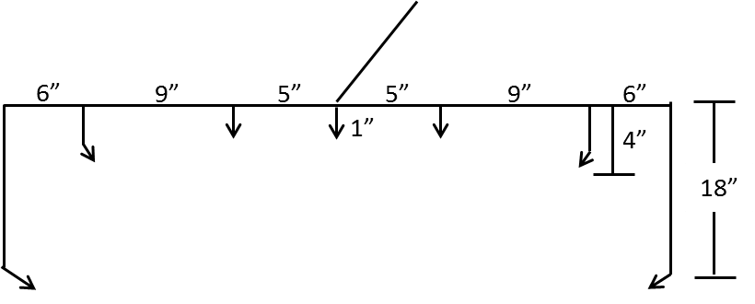
2. 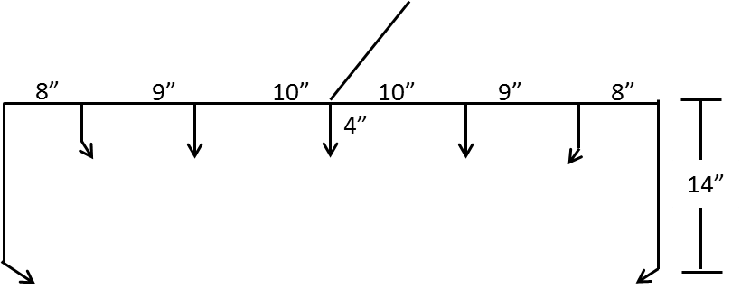

C-E) 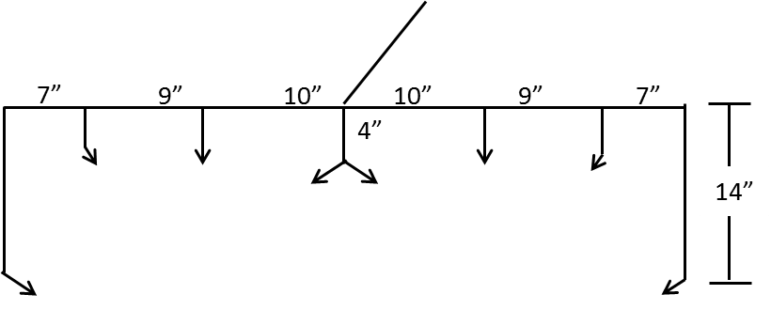

*Evaluations:*

Powdery Mildew (*Erysiphe cruciferarum*) severity was rated at six evaluation intervals beginning September 5 until October 10, using a 0-100 scale which roughly corresponded to percentage of plant infected with disease symptoms (mildew presence, wilting, leaf damage, etc.). Pest incidence, Area Under the Disease Progress Curve (AUDPC) and percent control were calculated from severity.

Harvest data was collected with small, medium, large and extra-large zucchini counts and weights recorded. The gross returns were calculated based on a value of $6.50 to $7.50 per 20 to 27-pound carton (depending on size) per commodity pricing published by thepacker.com.

All calculations were carried out using ARM9 Software (Gylling Data Management). Statistics were analyzed using ANOVA means comparison with LSD test and α=0.05. Bartlett’s test for homogeneity of variances was used to determine the need for data transformations.

RESULTS

**Table 1. Pest Severity – Powdery Mildew.** Severity of powdery mildew infection on Ambassador Zucchini rated on a 0-100 scale, where 0 is uninfected and 100 is total plant infection.



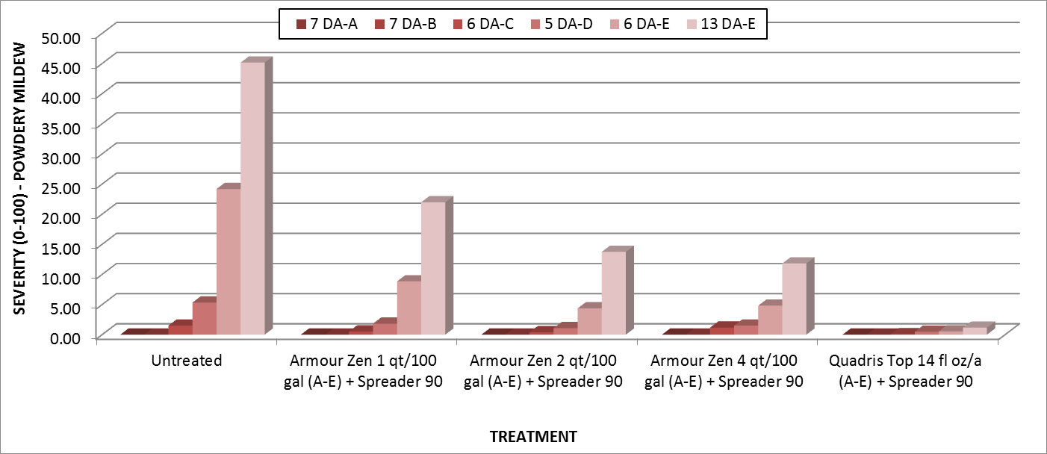

**Table 1. Pest Severity – Powdery Mildew.** Severity of powdery mildew infection on Ambassador Zucchini rated on a 0-100 scale, where 0 is uninfected and 100 is total plant infection.

**Table 2. Percent Incidence – Powdery Mildew.** Calculated percent incidence of disease symptoms based on rated severity.



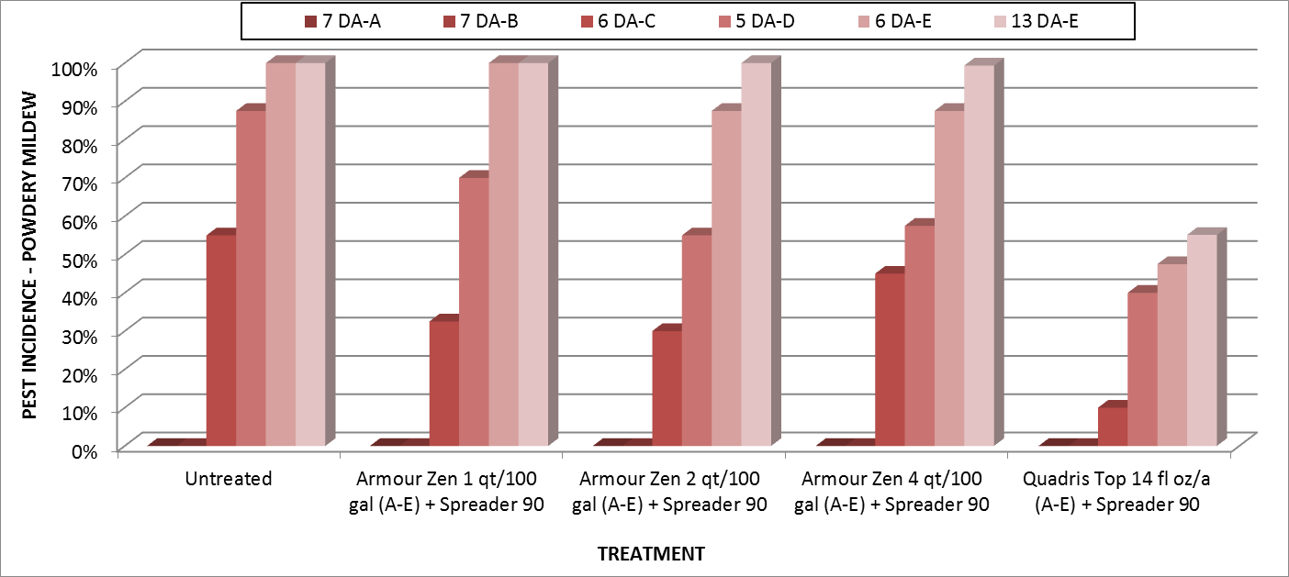

**Chart 2. Percent Incidence – Powdery Mildew.** Calculated percent incidence of disease symptoms based on rated severity.

**Table 3. AUDPC – Powdery Mildew** Area under the disease progress curve calculated from severity ratings 7 DA-A to 13 DA-E.



Note: AUDPC calculates the average disease intensity between each pair of adjacent time points. It is calculated by determining the average distance in rise of disease intensity for each evaluation date and adding them together by treatment.

$$\sum_{t=1}^{Νi-1}{\frac{y_{i}-y_{i-1}}{2}}(t_{i}-t_{1-1})$$

Where y = severity, t=time, N=average disease intensity between two adjacent time points.

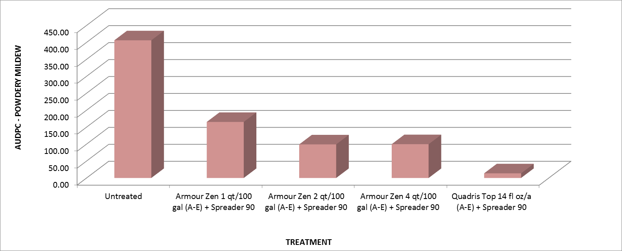

**Chart 3. AUDPC – Powdery Mildew** Area under the disease progress curve calculated from severity ratings 7 DA-A to 13 DA-E.

**Table 4. Percent Control – Powdery Mildew.** Percent control of Powdery Mildew infection based on severity ratings from 7 DA-A to 13 DA-E.



Note: This percent control expresses the severity of Fungal Disease infection in treated plots, compared to plants in the untreated check. It was calculated using the Abbott formula.

|  |  |  |  |  |  |
| --- | --- | --- | --- | --- | --- |
| Corrected % = (1 - | |  | | --- | | n in T after treatment | | http://www.ehabsoft.com/ldpline/line.gif | | n in Co after treatment | | ) * 100 |

Where: n = disease pressure, T = treated, Co = control

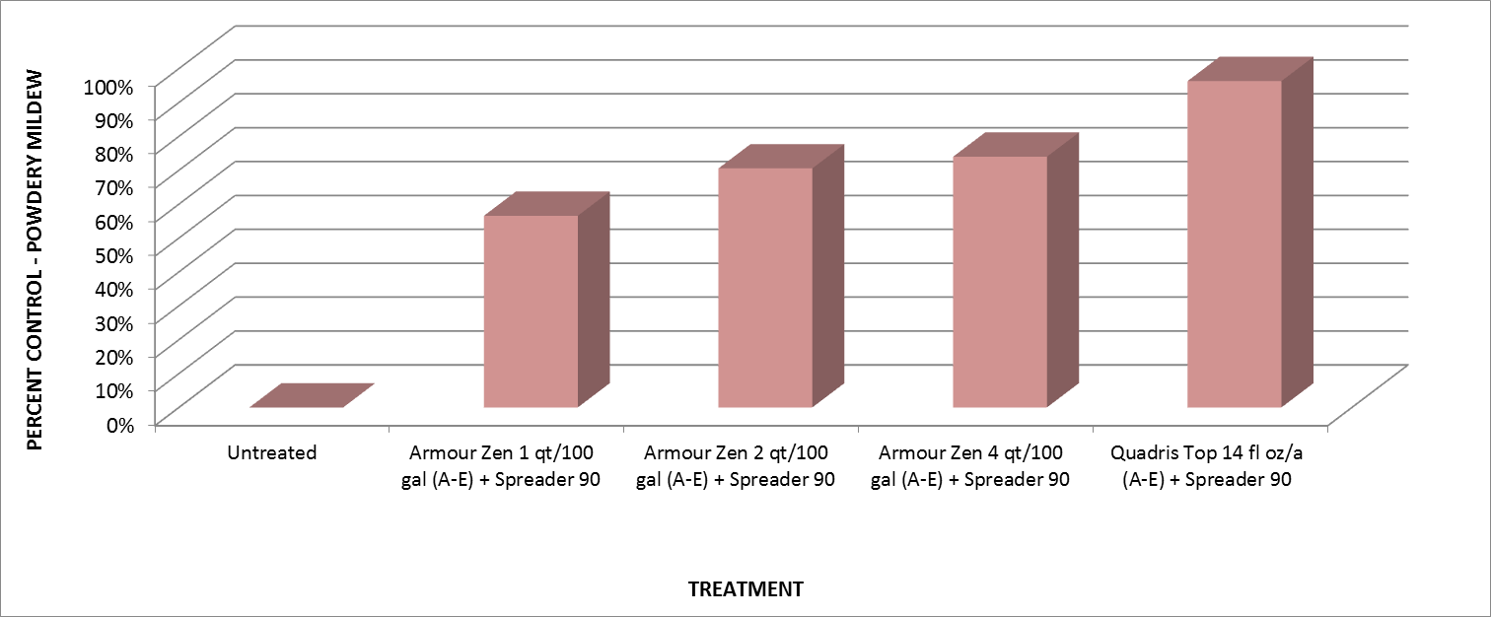

**Chart 4. Percent Control – Powdery Mildew.** Percent control of Powdery Mildew infection based on severity ratings from 7 DA-A to 13 DA-E.

**Table 5. Small Zucchini Weight (kg).** Weight (in kilograms) of small-sized zucchini (approximately 21 pounds per carton) harvested at 8 intervals.



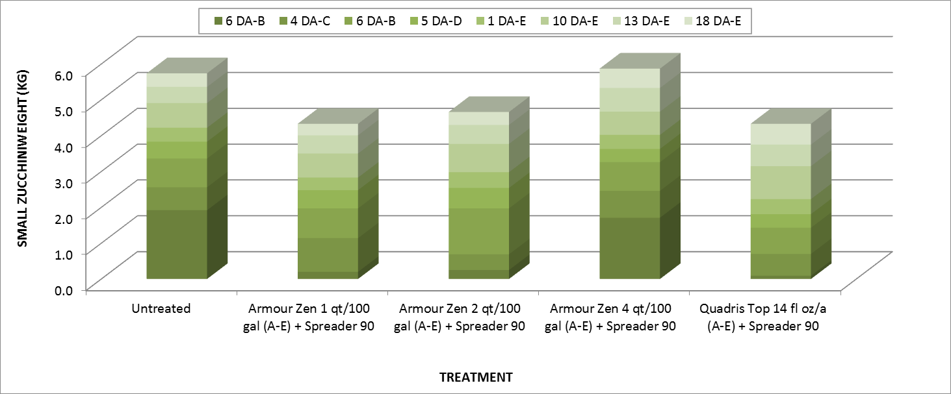

**Chart 5. Small Zucchini Weight (kg).** Weight (in kilograms) of small-sized zucchini (approximately 21 pounds per carton) harvested at 8 intervals.

**Table 6. Medium Zucchini Weight (kg).** Weight (in kilograms) of medium-sized zucchini (approximately 21 pounds per carton) harvested at 8 intervals.



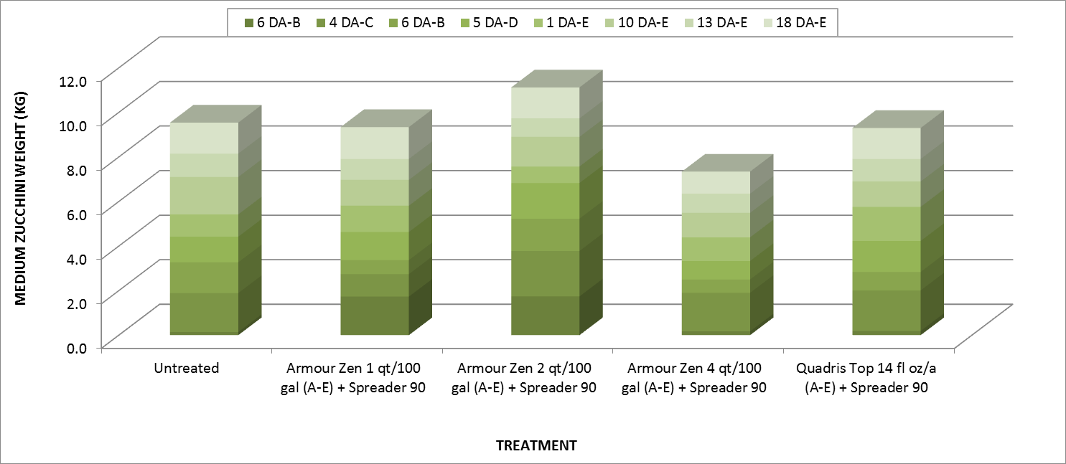

**Chart 6. Medium Zucchini Weight (kg).** Weight (in kilograms) of medium-sized zucchini (approximately 21 pounds per carton) harvested at 8 intervals.

**Table 7. Large Zucchini Weight (kg).** Weight (in kilograms) of large-sized zucchini (approximately 20 pounds per carton) harvested at 8 intervals.



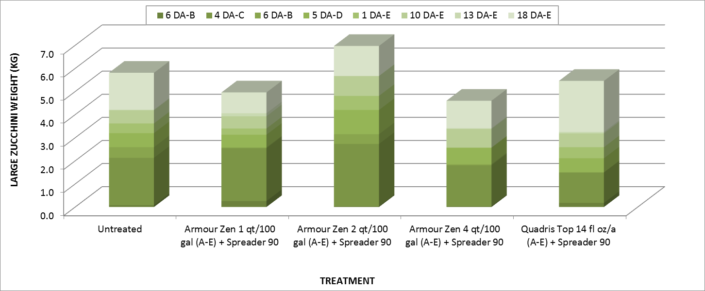

**Chart 7. Large Zucchini Weight (kg).** Weight (in kilograms) of large-sized zucchini (approximately 20 pounds per carton) harvested at 8 intervals.

**Table 8. Extra-Large Zucchini Weight (kg).** Weight (in kilograms) of extra-large-sized zucchini (approximately 20 pounds per carton) harvested at 8 intervals.



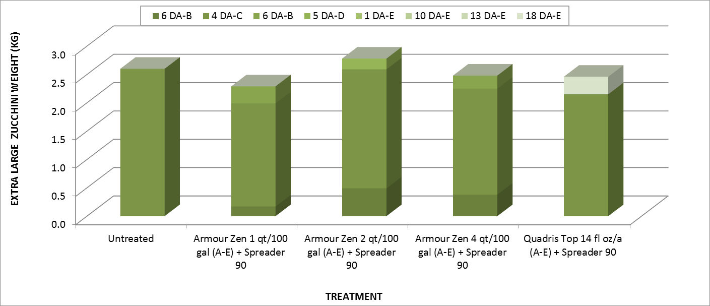

**Chart 8. Extra-Large Zucchini Weight (kg).** Weight (in kilograms) of extra-large-sized zucchini (approximately 20 pounds per carton) harvested at 8 intervals.

**Table 9. Total Yield (Percent).** Percent of total yield determined to be small, medium, large or extra-large.



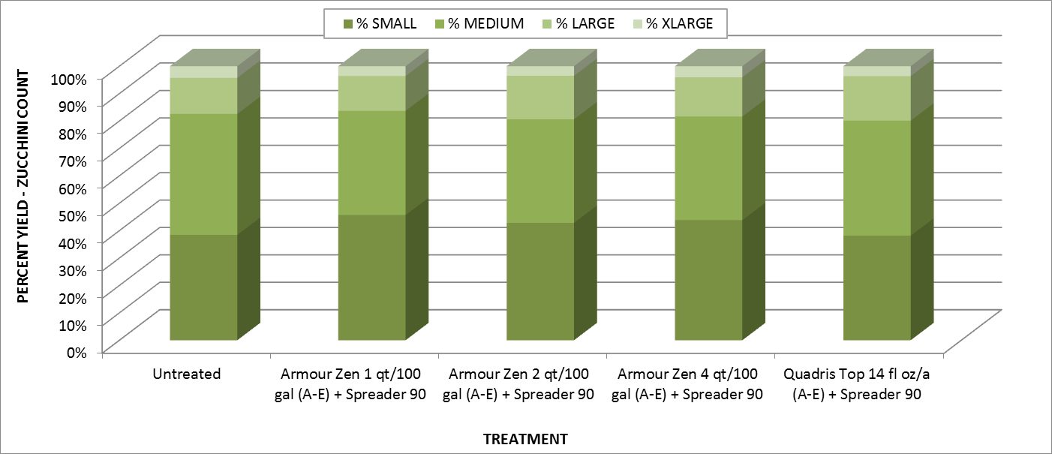

**Chart 9. Total Yield (Percent).** Percent of total yield determined to be small, medium, large or extra-large.

**Table 10. Cartons/Acre.** Average number of cartons yielded per acre, at eight harvests for approximate weights of 20-21 pounds per carton (depending on size).



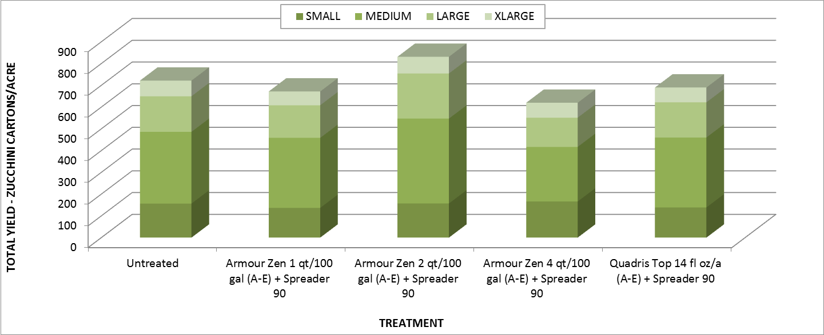

**Chart 10. Cartons/Acre.** Average number of cartons yielded per acre, at eight harvests for approximate weights of 20-21 pounds per carton (depending on size).

**Table 11. Gross Return.** Average return on cartons, in dollars per acre, at harvest for an approximate value of $6.50 or $7.50/carton (depending on size).



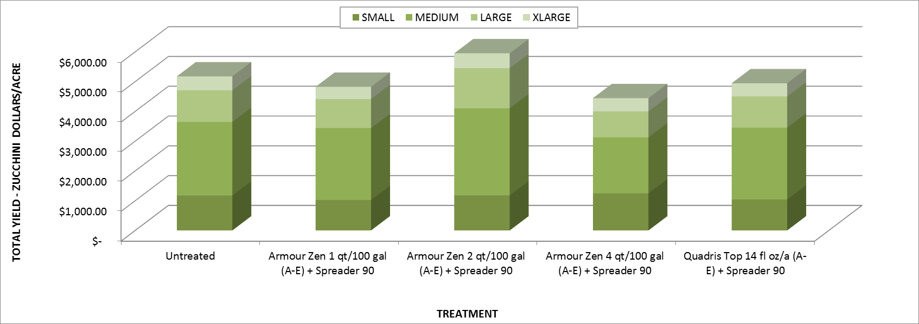

**Chart 11. Gross Return.** Average return on cartons, in dollars per acre, at harvest for an approximate value of $6.50 or $7.50/carton (depending on size).

TREATMENT LIST



PLOT MAP



CROP INFORMATION

|  |  |  |  |
| --- | --- | --- | --- |
| Principal Investigator: | Kevin Coons | Location: | Guadalupe Ranch 2 |
|  |  |  |  |
| Study Director: | Duane Ewing | Grower: | Pacific Ag Research |
|  |  |  |  |
| Crop: | Zucchini | Date/Duration: | August - October 2013 |
|  |  |  |  |
| Cultivar: | Ambassador | Planting Date: | 7/25/2013 |
|  |  |  |  |
| Test Products: | ARMOUR-Zen | Planting Method: | Hand |
|  |  |  |  |
| Pest Species: | Powdery Mildew | Harvest Method: | Hand |
|  | *Podosphera xanthii* |  |  |
|  | Efficacy for control of ARMOUR-Zen against Powdery Mildew in Squash | Adjuvants: | Spreader 90 |
|  |  |  |
| Objective: | Application Method: | Backpack CO2 |
|  |  |  |
|  |  | Calibration Method: | Timed Recapture |
| Plot Dimensions: | 3.33' x 40' |  |  |
|  |  | Nozzle Type: | TG-1 x 6 |
| Experiment Size: | 0.06 acres |  |  |
|  |  | Nozzle Height: | 18" |
| Planting Density: | 13,081 Plants/Acre |  |  |
|  |  | Operating Pressure: | 50 PSI |
| Row Spacing: | 3.33' |  |  |
|  |  | Spray Boom Width: | 40" |
| Soil Type: | Sandy Loam |  |  |
|  |  | Dilution: | 50 GPA |
| Plant Spacing: | 24" |  |  |
|  |  | Irrigation Method: | Drip |
| No. Treatments/Reps: | 5 Treatments / 4 Replicates |  |  |
|  |  | Application Dates: | 8/29,9/5,9/12,9/19,9/27 |
| Statistical Design: | RCB |  |  |
|  |  | Evaluation Dates: | 9/5,9/12,9/18,9/24,10/3,10/10 |
| No. Applications: | 5 |  |  |
|  |  |  |  |
| Appl. Frequency: | 7 Day |  |  |

APPENDIX A: DAILY METEROLOGICAL SUMMARY:

GUADALUPE, CA

|  |  |  |  |  |  |  |
| --- | --- | --- | --- | --- | --- | --- |
| **Date** | **Precip (in)** | **Cumulative Rainfall** | **Max (F°)** | **Min (F°)** | **Mean (F°)** | **Rel Hum%** |
| 1-Aug-13 | 0.00 | 0.00 | 69.7 | 48.1 | 58.7 | 42 |
| 2-Aug-13 | 0.00 | 0.00 | 66.3 | 46.7 | 56.1 | 38 |
| 3-Aug-13 | 0.00 | 0.00 | 67.0 | 51.7 | 56.6 | 39 |
| 4-Aug-13 | 0.00 | 0.00 | 67.0 | 51.0 | 56.7 | 38 |
| 5-Aug-13 | 0.00 | 0.00 | 64.2 | 51.7 | 56.1 | 41 |
| 6-Aug-13 | 0.00 | 0.00 | 65.6 | 51.0 | 56.5 | 42 |
| 7-Aug-13 | 0.00 | 0.00 | 67.7 | 51.0 | 57.8 | 39 |
| 8-Aug-13 | 0.00 | 0.00 | 66.3 | 49.6 | 58.1 | 38 |
| 9-Aug-13 | 0.00 | 0.00 | 66.3 | 53.1 | 58.7 | 36 |
| 10-Aug-13 | 0.00 | 0.00 | 65.6 | 53.1 | 58.1 | 40 |
| 11-Aug-13 | 0.00 | 0.00 | 64.9 | 53.1 | 57.4 | 44 |
| 12-Aug-13 | 0.00 | 0.00 | 67.0 | 52.4 | 57.6 | 48 |
| 13-Aug-13 | 0.00 | 0.00 | 67.7 | 51.7 | 57.6 | 50 |
| 14-Aug-13 | 0.00 | 0.00 | 68.4 | 48.8 | 58.2 | 46 |
| 15-Aug-13 | 0.01 | 0.01 | 75.3 | 49.6 | 60.2 | 52 |
| 16-Aug-13 | 0.00 | 0.01 | 72.5 | 52.4 | 59.5 | 51 |
| 17-Aug-13 | 0.01 | 0.02 | 67.0 | 53.1 | 58.8 | 56 |
| 18-Aug-13 | 0.00 | 0.02 | 71.1 | 53.8 | 59.1 | 51 |
| 19-Aug-13 | 0.00 | 0.02 | 71.1 | 53.1 | 59.4 | 47 |
| 20-Aug-13 | 0.00 | 0.02 | 72.5 | 50.3 | 59.5 | 41 |
| 21-Aug-13 | 0.00 | 0.02 | 73.2 | 45.9 | 58.1 | 38 |
| 22-Aug-13 | 0.00 | 0.02 | 74.6 | 45.2 | 59.5 | 54 |
| 23-Aug-13 | 0.00 | 0.02 | 70.4 | 48.1 | 58.0 | 45 |
| 24-Aug-13 | 0.00 | 0.02 | 74.6 | 53.8 | 60.2 | 40 |
| 25-Aug-13 | 0.00 | 0.02 | 74.6 | 54.5 | 60.5 | 43 |
| 26-Aug-13 | 0.00 | 0.02 | 71.8 | 54.5 | 60.7 | 44 |
| 27-Aug-13 | 0.00 | 0.02 | 68.4 | 53.1 | 59.1 | 45 |
| 28-Aug-13 | 0.03 | 0.05 | 71.1 | 53.1 | 59.4 | 50 |
| 29-Aug-13 | 0.00 | 0.05 | 73.9 | 54.5 | 61.2 | 48 |
| 30-Aug-13 | 0.00 | 0.05 | 78.1 | 53.1 | 64.7 | 47 |
| 31-Aug-13 | 0.00 | 0.05 | 82.3 | 55.9 | 66.8 | 35 |
| 1-Sep-13 | 0.00 | 0.05 | 80.9 | 57.3 | 66.7 | 34 |
| 2-Sep-13 | 0.00 | 0.05 | 76.0 | 55.9 | 64.1 | 39 |
| 3-Sep-13 | 0.00 | 0.05 | 79.5 | 55.9 | 65.3 | 36 |
| 4-Sep-13 | 0.00 | 0.05 | 77.4 | 51.7 | 61.9 | 39 |
| 5-Sep-13 | 0.00 | 0.05 | 75.3 | 54.5 | 62.3 | 37 |
| 6-Sep-13 | 0.00 | 0.05 | 72.5 | 48.8 | 59.7 | 39 |
| 7-Sep-13 | 0.01 | 0.06 | 71.1 | 48.1 | 58.4 | 44 |
| 8-Sep-13 | 0.00 | 0.06 | 69.0 | 53.8 | 58.7 | 44 |
| 9-Sep-13 | 0.00 | 0.06 | 71.1 | 53.1 | 59.0 | 46 |
| **Date** | **Precip (in)** | **Cumulative Rainfall** | **Max (F°)** | **Min (F°)** | **Mean (F°)** | **Rel Hum%** |
|  |  |  |  |  |  |  |
| 10-Sep-13 | 0.01 | 0.07 | 73.9 | 54.5 | 61.2 | 45 |
| 11-Sep-13 | 0.00 | 0.07 | 74.6 | 49.6 | 60.5 | 44 |
| 12-Sep-13 | 0.00 | 0.07 | 72.5 | 45.2 | 58.1 | 43 |
| 13-Sep-13 | 0.00 | 0.07 | 70.4 | 53.1 | 59.5 | 44 |
| 14-Sep-13 | 0.00 | 0.07 | 72.5 | 51.7 | 59.3 | 44 |
| 15-Sep-13 | 0.00 | 0.07 | 71.8 | 48.1 | 58.3 | 39 |
| 16-Sep-13 | 0.01 | 0.08 | 71.1 | 52.4 | 58.6 | 45 |
| 17-Sep-13 | 0.00 | 0.08 | 71.8 | 50.3 | 60.1 | 39 |
| 18-Sep-13 | 0.00 | 0.08 | 85.9 | 44.5 | 59.3 | 35 |
| 19-Sep-13 | 0.00 | 0.08 | 82.3 | 42.3 | 57.6 | 34 |
| 20-Sep-13 | 0.00 | 0.08 | 77.4 | 51.0 | 59.3 | 42 |
| 21-Sep-13 | 0.00 | 0.08 | 73.9 | 55.9 | 61.7 | 40 |
| 22-Sep-13 | 0.02 | 0.10 | 73.9 | 47.4 | 59.5 | 41 |
| 23-Sep-13 | 0.00 | 0.10 | 88.8 | 51.0 | 67.0 | 21 |
| 24-Sep-13 | 0.00 | 0.10 | 80.9 | 43.7 | 58.4 | 30 |
| 25-Sep-13 | 0.11 | 0.21 | 71.8 | 43.0 | 55.8 | 32 |
| 26-Sep-13 | 0.00 | 0.21 | 70.4 | 38.5 | 53.5 | 32 |
| 27-Sep-13 | 0.00 | 0.21 | 80.2 | 35.4 | 56.2 | 28 |
| 28-Sep-13 | 0.00 | 0.21 | 89.6 | 39.3 | 58.2 | 21 |
| 29-Sep-13 | 0.00 | 0.21 | 78.8 | 41.5 | 56.6 | 24 |
| 30-Sep-13 | 0.00 | 0.21 | 78.8 | 41.5 | 57.9 | 30 |
| 1-Oct-13 | 0.01 | 0.22 | 73.2 | 49.6 | 58.8 | 47 |
| 2-Oct-13 | 0.00 | 0.22 | 70.4 | 44.5 | 53.9 | 39 |
| 3-Oct-13 | 0.01 | 0.23 | 69.7 | 40.0 | 52.4 | 35 |
| 4-Oct-13 | 0.00 | 0.23 | 83.0 | 43.0 | 60.3 | 22 |
| 5-Oct-13 | 0.00 | 0.23 | 93.3 | 37.7 | 59.9 | 23 |
| 6-Oct-13 | 0.00 | 0.23 | 97.9 | 43.0 | 62.3 | 19 |
| 7-Oct-13 | 0.00 | 0.23 | 68.4 | 42.3 | 54.6 | 27 |
| 8-Oct-13 | 0.00 | 0.23 | 65.6 | 48.8 | 55.0 | 34 |
| 9-Oct-13 | 0.10 | 0.33 | 62.2 | 42.3 | 52.5 | 33 |
| 10-Oct-13 | 0.00 | 0.33 | 69.0 | 37.7 | 52.4 | 37 |
| 11-Oct-13 | 0.00 | 0.33 | 70.4 | 40.0 | 53.6 | 41 |
| 12-Oct-13 | 0.00 | 0.33 | 69.0 | 42.3 | 54.0 | 39 |
| 13-Oct-13 | 0.00 | 0.33 | 69.7 | 45.2 | 53.6 | 37 |
| 14-Oct-13 | 0.00 | 0.33 | 77.4 | 40.0 | 56.4 | 33 |
| 15-Oct-13 | 0.00 | 0.33 | 91.0 | 39.3 | 59.1 | 23 |
| 16-Oct-13 | 0.00 | 0.33 | 91.0 | 42.3 | 59.8 | 20 |
| 17-Oct-13 | 0.00 | 0.33 | 75.3 | 39.3 | 55.5 | 22 |
| 18-Oct-13 | 0.00 | 0.33 | 82.3 | 40.0 | 55.8 | 24 |
| **Date** | **Precip (in)** | **Cumulative Rainfall** | **Max (F°)** | **Min (F°)** | **Mean (F°)** | **Rel Hum%** |
|  |  |  |  |  |  |  |
| 19-Oct-13 | 0.02 | 0.35 | 71.8 | 42.3 | 54.0 | 41 |
| 20-Oct-13 | 0.00 | 0.35 | 74.6 | 48.1 | 54.7 | 43 |
| 21-Oct-13 | 0.00 | 0.35 | 71.1 | 48.8 | 54.5 | 40 |
| 22-Oct-13 | 0.00 | 0.35 | 69.7 | 47.4 | 54.9 | 39 |
| 23-Oct-13 | 0.00 | 0.35 | 67.7 | 50.3 | 54.7 | 39 |
| 24-Oct-13 | 0.00 | 0.35 | 62.8 | 43.0 | 53.9 | 39 |
| 25-Oct-13 | 0.00 | 0.35 | 70.4 | 45.9 | 54.4 | 40 |
| 26-Oct-13 | 0.00 | 0.35 | 69.0 | 44.5 | 55.2 | 51 |
| 27-Oct-13 | 0.01 | 0.36 | 59.4 | 48.8 | 54.0 | 53 |
| 28-Oct-13 | 0.22 | 0.58 | 60.1 | 47.4 | 53.6 | 41 |
| 29-Oct-13 | 0.00 | 0.58 | 70.4 | 43.7 | 54.2 | 44 |
| 30-Oct-13 | 0.01 | 0.59 | 75.3 | 36.9 | 52.6 | 39 |
| 31-Oct-13 | 0.00 | 0.59 | 83.0 | 36.9 | 53.6 | 30 |

APPENDIX B: SOIL ANALYSIS

